i281e  
Technical User Manual

Procedures and Operation

DC-281001

May 2024

# TABLE OF CONTENTS

# Chapter 1: Introduction

# Chapter 2: Hardware Operation

# Chapter 3: Processor Theory

# Chapter 4: i281e Programming

# Chapter 5: Managing Memory

# Chapter 6: Interfacing with Devices

# Chapter 7: Advanced Programming Techniques

# Chapter 8: DOS/281

# Appendix A: Electrical Schematics

Figure 1 - Modules Labeled on i281e CPU 4

Figure 2 - Mainboard PCB without Most Components 5

Figure 3 - Code Memory Schematic 15

Figure 4 - Abstract register file representation. 22

Figure 5 – 8-bit register using D flip-flops. 22

Figure 6 - Detailed abstraction of register file module 23

Figure 7 – 3-to-8 decoder using control signals of the register file 24

Figure 8 – 2-to-4 decoder with enable using control signals of the register file 24

Figure 9 - 8-bit 4-to-1 MUX 25

Figure 10 - Octal latch register with active low enable (Register A) 26

Figure 11 - Dual 2-to-4 decoder with active low enable and outputs 27

Figure 12 - 8-bit LED display with resistor network 27

Figure 13 - Dual 4-to-1 MUX chips being used as an 8-bit 4-to-1 circuit (Port 0) 28

Figure 14 - PCB implementation of the register file (Revision A) 29

Figure 15 - ALU Subcomponents Diagram 30

Figure 16 - ALU Arithmetic Mode Table 30

Figure 17 - ALU Shifter Design 31

Figure 18 - ALU Addition/Subtraction Design with Flags 31

Figure 19 - ALU NOR Arithmetic Mode Table 32

Figure 20 - ALU NOR Shifter 32

Figure 21 - ALU Schematic Addition/Subtraction Module 33

Figure 22 - ALU Schematic Shifter Module 34

Figure 23 - ALU NOR Schematic Shifter Module 34

Figure 24 - ALU Schematic Output and Flag Calculator 35

Figure 25 - ALU Output Visualization 36

Figure 26 - ALU Flag Register Visualization 36

Figure 27 - ALU Control Line Visualization 37

Figure 28 - ALU PCB 38

Figure 29 - ALU NOR PCB 39

# Chapter 1: Introduction

Welcome to the User Manual for the i281e Processor Manual. This handbook is designed to serve as a comprehensive guide for both understanding how the i281 processor works and learning how to use it effectively. Whether you are a student delving into CPU architecture for the first time or an experienced user seeking to enhance your knowledge, this manual will provide you with the essential information and practical instructions needed to navigate the intricacies of the i281e processor. Through clear explanations, illustrative examples, and step-by-step tutorials, you will gain a deep understanding of the processor's design principles, functionality, components, and operation.

The i281e is a processor created for the purpose of student learning. Each component has been created with this in mind. LEDs have been added all over the machine to help with visualization. Clock speed is adjustable anywhere from 3MHz all the way down to step by step at the push of a button. With this feature, you can see what the processor does at each clock cycle. Each main module is removable to help get a closer look at the parts that make up each piece. Schematics are available to assist anyone who would wish to recreate anything from this processor.

coThe i281 processor had its beginnings in the summer of 2019 when the FPGA form in the Altera board was created, made completely out of logic gates. In the spring of 2021, Dr. Alexander Stoytchev and his senior design group created an online simulator version of the processor to easily demonstrate its inner workings. The next step was to transfer it into hardware, which required making some minor modifications, resulting in the i281e. After implementing it into a fully operational breadboard version, the PCB version was devised and created. After years of work, countless renditions, and multiple PCB versions later, the processor as you see it now was born.

For ease of reading and understanding, chapters of this manual have been prepared to start with basics and major hardware concerns, and then move on to more advanced applications like programming and device capabilities. A synopsis of each chapter is provided below to assist in navigating this manual.

Chapter 2: Hardware Facilities

Delve into the foundational aspects of the i281e's hardware infrastructure, covering crucial topics such as module layout and orientation. Utilize visual aids and detailed descriptions to understand the locations of each module within the system and learn safe attachment and detachment procedures. Explore power management protocols, including guidelines for plugging in and powering up the system securely, alongside essential ESD protection measures.

Chapter 3: Processor Theory

Navigate the intricate theoretical frameworks underpinning the i281e's design principles, focusing on each of the components. The Code Memory (CMEM), Register file, Arithmetic Logic Unit (ALU), Program Counter, Control Table, Mainboard, and Interface panel are all covered in this module. Explore design theories for each component, including their general implementation, inputs, visualization, and outputs. Gain a comprehensive understanding of microarchitecture, instruction execution cycles, and computational processes specific to the i281e environment.

Chapter 4: i281e Programming

Unlock the realm of assembly language programming tailored for the i281e processor, emphasizing code optimization, memory management, and efficient utilization of instruction sets. Acquire practical programming skills, debugging strategies, and software development methodologies essential for harnessing the full potential of the i281e's architecture. Explore software tools, development environments, and debugging utilities to streamline the programming process.

Chapter 5: Managing Memory

Explore advanced memory management techniques within the i281e architecture context, including virtual memory, paging, and memory segmentation. Dive into memory organization principles, address space allocation strategies, and data access optimization methods crucial for designing robust memory systems. Gain insights into cache coherence, memory hierarchy, and memory protection mechanisms to ensure data integrity and system reliability.

Chapter 6: Interfacing with Devices

Master device interfacing methodologies, including I/O protocols, peripheral communication standards, and device driver development for seamless integration with the i281e platform. Learn to integrate sensors, actuators, and communication modules efficiently for responsive system interaction. Explore real-time systems, interrupt handling, and asynchronous communication to design scalable embedded systems.

Chapter 7: Advanced Programming Techniques

Elevate your programming proficiency with advanced techniques like multitasking, concurrent programming, and synchronization mechanisms specific to the i281e environment. Develop complex applications leveraging parallel processing, resource allocation, and task management capabilities for optimal software performance. Explore optimization strategies, profiling tools, and performance tuning to maximize software efficiency and responsiveness.

Chapter 8: DOS/281

Explore operating system concepts tailored to the i281e platform, covering process management, file systems, and system administration tasks. Gain practical knowledge for system initialization, user interface development, and system maintenance to create robust and user-friendly computing environments. Explore system security, memory protection, and recovery mechanisms to ensure system reliability and data integrity.

Appendix A: Electrical Schematics

Refer to detailed electrical schematics and circuit diagrams for understanding the i281e processor's hardware components and configurations. Utilize supplementary information on signal timings, power distribution, and component specifications to troubleshoot issues and seamlessly integrate the processor into various systems. Explore protocols for troubleshooting hardware problems, designing custom interfaces, and ensuring optimal performance of the i281e's electrical infrastructure.

# Chapter 2: Hardware Facilities

Chapter 2 should provide all necessary information that is required to fully use, maintain, and apply the i281e CPU. Below, the categories are split into several different sections each with their own purpose and set of instructions.

## Layout of the Modules

### Layout of the i281e CPU

From Figure 1, we can see the proper alignment and orientation of the modules. Use this Figure as a reference to the installation of the modules. When installing the modules onto the Mainboard, ensure that the i281e CPU logo is in the bottom left corner. There are 10 modules on the Mainboard, and 4 of them are the same MUX Module used multiple times in different orientations. As a general rule of thumb, for all modules excluding the MUX Modules, all of the module titles silkscreens should be angled the same way as the text on the Mainboard.

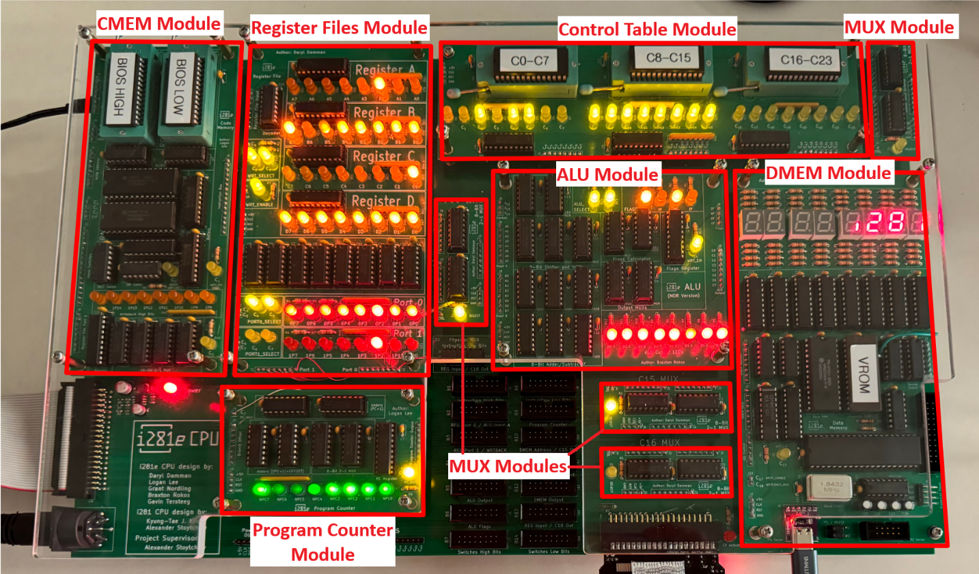

Figure 1 - Modules Labeled on i281e CPU

Additionally, if we look at Figure X, we can see the layout of the Mainboard. Each of the modules have a location designated by the silkscreen. The four holes of the larger modules match up with the four holes on the backboards of the desired location. This is where the mounting hardware will connect the modules securely to the backboard in addition to the Polycarbonate top and bottom covers (Can be seen in Figure X).

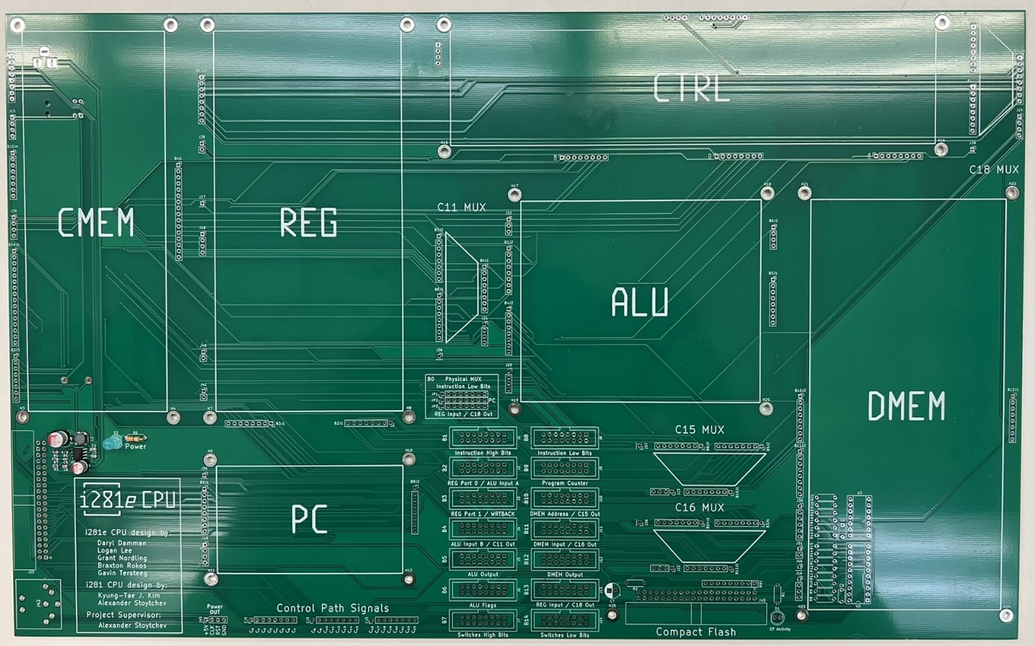

Figure 2 - Mainboard PCB without Most Components

### Methods of Attachment/Detachment

To safely attach the module to the Mainboard, ensure the mounting hardware is installed in the holes on the Mainboard. The mounting hardware is done in a “sandwich” design.

* Layer 1
  + 1/4” acrylic/polycarbonate panel with screw holes appropriately aligned.
  + There shall be five >10mm rubber feet in cross formation underneath the acrylic/polycarbonate panel.
* Layer 2
  + Mainboard PCB
* Layer 3
  + Respective modules (REG, PC, DMEM, etc.) will be seated on the pin headers.
* Layer 4
  + 1/4” acrylic/polycarbonate panel using top panel A or B (see hardware repository).

In between each layer, there will be respective standoffs and spacers to ensure the hardware remains in a soundly rigid fashion. See Figure X for an example of this sandwich design put together. The hardware repository contains information regarding the exact part information. The following steps should be taken for each accessible mounting location.

* Layer 1
  + Insert screws with one washer inserted bottom-up with male-to-female standoff fastened with the male end facing upward.
* Layer 2
  + Set the Mainboard PCB on-top of the upright standoffs and fasten two washers and a spacer.
* Layer 3
  + Set each respective module in the correct orientation and fasten male-to-female standoffs with the male end facing downward.
* Layer 4
  + Set top panel A or B and fasten screws with one washer into female receptacle of standoff.

Some PCB modules cannot be attached to the top panel and will need to have a screw with washer inserted at Layer 3. Once the mounting hardware is installed, one can line up the corners of the module with the 4 mounts. Take note of the orientation of the module aligning it. Once you are ready to attach the module, simply press down on the module evenly. If done correctly, all the pin headers should have gone into their corresponding receptors on the Mainboard.

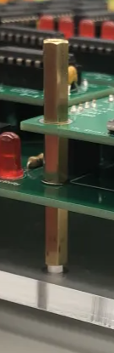

Figure 3 - Mounting Hardware

To safely detach a module from the Mainboard, ensure that the acrylic top sheet is no longer attached to the boards and the top 10mm spacer is removed. With even strength, pull up on the module. The module should pull up without too significant of force. If you are having a hard time detaching the module, double check nothing is restricting you. If there are no restrictions, hold the module by its input and output header edges and wiggle it back and forth until it starts to give way. Be gentle to not bend pins or crack a solder joint.

## Power / Power Safety

One of the most important things to know about the i281e CPU is how to turn it on properly. Questions you may be thinking to yourself might be “Do I need to wear an anti-static wrist strap?” or “How do I know if the CPU is on?” This section will give you all the answers to those questions and ensure that the CPU is not damaged in the process to turning it on or using the device.

IMPORTANT:

When using the i281e CPU, one MUST wear an anti-static wrist strap or alternative ESD protection equipment/methods.

An anti-static wrist strap will prevent electrostatic discharge (ESD) from damaging the CPU. ESD can damage the IC chips or alter their programming. In order to prevent damage, always ensure that you are grounded prior to touching the equipment, this includes plugging in the anti-static wrist strap into the designated areas. Most lab tables and desks have ports in them that correspond to the pin at the end of your anti-static wrist strap. If your anti-static wrist strap has a clip at the end, connect it to something made out of metal that is not painted. It is preferred that you ground yourself to a table or alternative location, but there are always options. When anti-static wrist straps are not provided, this grounding could be as simple as touching an unpainted metal object prior to touching the equipment. An anti-static wrist strap overall is a simple method to ensure you do not harm the electronics.

How do I plug the i281e CPU in?

First, you need to find the power cable and find an outlet to plug it into. The port to plug in the power cable is on the top left of the Mainboard. This port is on the underside of the Mainboard. With one hand, hold the Mainboard and with the other, insert the plug into the port. Ensure that it is a snug fit.

Second, press the button right next to the port on the underside of the Mainboard. Once you press the button, there should be a light blue LED (Rev B) that lights up near the bottom right of the mainboard. Once this LED is lit, the CPU is on. Power will be provided to the board and the startup sequence for the i281e CPU must be achieved.

If the LED is not powered on when pressing the button, the plug may not be fully in. Ensure that the plug is firmly pressed into the slot.

## Front Panel Usage

The switches on the front panel are the main tool to interact with the i281e CPU and influence its operation. A diagram with the switch layout is shown in Figure 4.

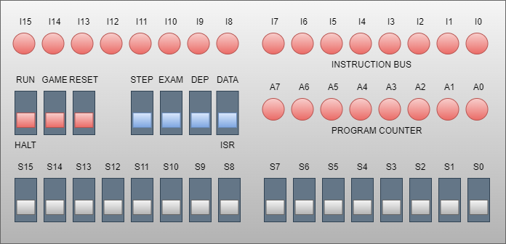

Figure 4 - User Panel Design

The red switches are used in the normal operation of the computer. The blue switches are specialty switches used for debugging, setup, and learning. The white switches are the normal input switches used in other designs.

The current location of the program counter is shown with green LEDs in the middle right. The top red LEDs show the current instruction line outputted by the code memory.

The PCB front panel design is shown in Figure 5, with each switch labeled.

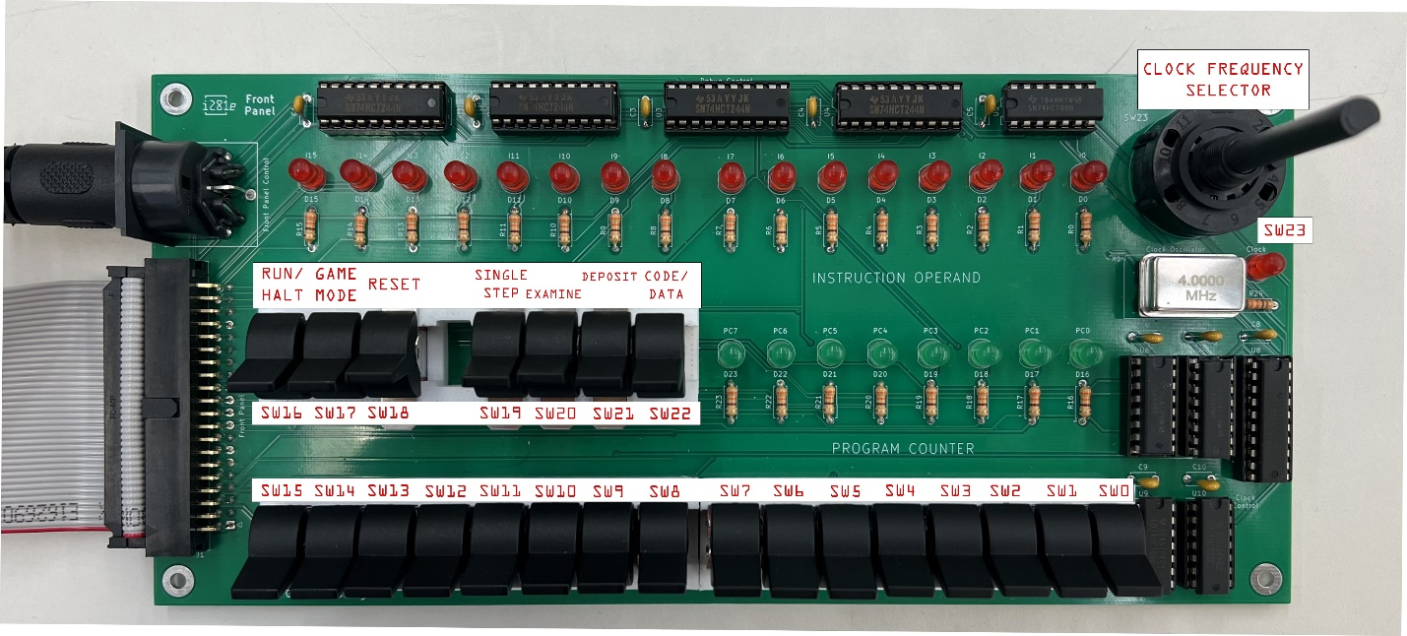

Figure 5 – Front Panel PCB

Switches 0-15 are the input switches to the i281e CPU. These are used to input data into the computer manually. They are utilized when manually writing programs to RAM, when the program is expected to input like in pong, and when using the debug switches to change the location of the program counter (this will be talked about later).

Switch 16 controls the clock; kind of like the clock’s enable switch. This works by allowing the clock frequency from the clock oscillator to propagate. Although other processes like the step switch pulse the clock, this stops the i281e from running. When turning the i281e CPU on, the computer should be in the halted state.

Switch 17 controls the game mode signal. This is a pseudo control signal that affects the operation of the video card. Normally, the video card reads the data memory and converts the data from binary to the decimal seven-segment equivalent; switch 17 is low. However, when switch 17 is active, the video card reads each bit in the data memory as an individual LED of the display. This is utilized in some programs, line pong, and banners.

Switch 18 is the reset line for the i281e CPU. The reset signal is sent to the rest of the i281e CPU when activated. The reset signal clears the program counter, the data bus, the compact flash register, and reset the UART.

Switch 19 performs a single step in the i281e CPU by pulsing the clock single once. The i281e should be in halt mode before using the single step switch to ensure stability. Single step is a helpful functionally to have and use when understanding how the process is working, allowing all the LEDs to be seen before an instruction is done.

Switch 20 is used for examine functionally. This allows the location of the program counter to be changed. When examine is active, the instruction bus is overridden with jump instruction; the eight lower switches are passed to the offset bus in the program counter. This allows for the location of the next location of the program counter to be set to any value using the input switches. The program counter's LEDs can be used to quickly tell where the program counter will go after releasing the switch. The i281e CPU needs to be in halt mode for stability.

Switch 21 is deposit and switch 22 is used as the code/data memory selection for deposit. These switches are used to load programs into the RAM chips and load numbers into data memory. When the switch is active, the instruction bus is over with the INPUTC/INPUTD instruction, and the switches are sent to the RAM chips and data memory input mux. After the switch is released back to the lower position, the instruction is executed and loaded into the corresponding location. The program counter is also increased by one in preparation for the next input. Switch 22 is in the lower position when writing to code memory and in the higher position when writing to data memory. These write locations are also located at different points in memory; RAM addresses start at 0x80, and data memory starts at 0x00. Examine will allow the i281e to move through these addresses for writing to and afterward when starting the program loaded into RAM.

The clock frequency selector is a 12-point rotary switch that allows one to choose from the 12 selected frequencies. The different frequencies available with a 4 MHz oscillator are shown in Table 1. The process shown be halt state before switch frequency to ensure stability.

Table 1 - Clock Frequencies

|  |  |
| --- | --- |
| Position | Frequency |
| 12 | 2 MHz |
| 11 | 1 MHz |
| 10 | 250 kHz |
| 9 | 62.5 kHz |
| 8 | 31.25 kHz |
| 7 | 7.81 kHz |
| 6 | 1.95 kHz |
| 5 | 244 Hz |
| 4 | 61.04 Hz |
| 3 | 7.63 Hz |
| 2 | 1.91 Hz |
| 1 | 954 mHz |

## I/O Ports

For the i281e CPU, there are several different types of ports. Some are used to connect the Front Panel and others are used to output data to other devices. From Figure X, we can see five different highlighted locations. The Front Panel Bus (40Pin) and the Front Control Bus (6DIN) are the two cables that connect the CPU to the Front Panel. See Figure X in the Front Panel Usage section to see how those two cables connect to the Front Panel on the left side. The Compact Flash Bus (40Pin) allows for a compact flash input adapter to connect to the board. From here we can load data into the system. The Serial I/O ports allow for RS-232 cables to connect the system. Additionally, not highlighted in the Figure X, you can see a USB-C cable sticking into the CPU. The USB-C is another method for inputting programs into the system. There is an Expansion Bus (24Pin) and power output bus which allows for input and output to newly created cards in the future. Additionally, there are also breakout pins, which the next section covers.

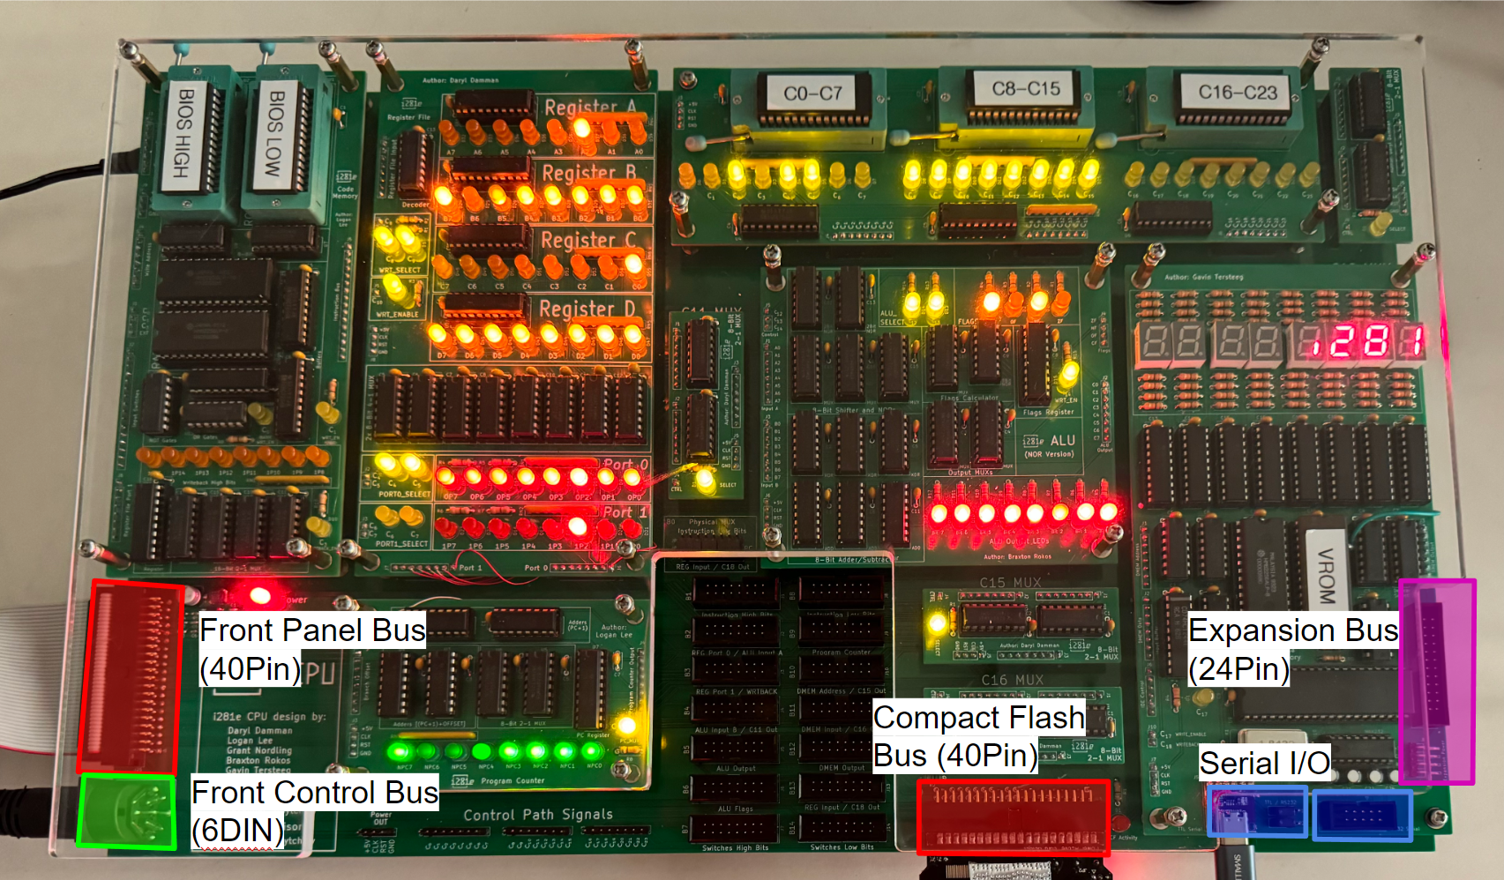

Figure 6 - IO Ports of the i281e CPU

## Breakout Pins

On the Mainboard in the bottom middle, there are 14 breakout female headers that can be used to connect breadboards to the i281e CPU. A specialized cable must be created that connects to those 16-bit female breakout header to the breadboard using another 16-bit male header. Figure X and X+1, below shows how the breakout headers are labeled and laid out on the i281e CPU. Each of the headers are labeled with a Reference Designator “BX”, X being a number 0-14.

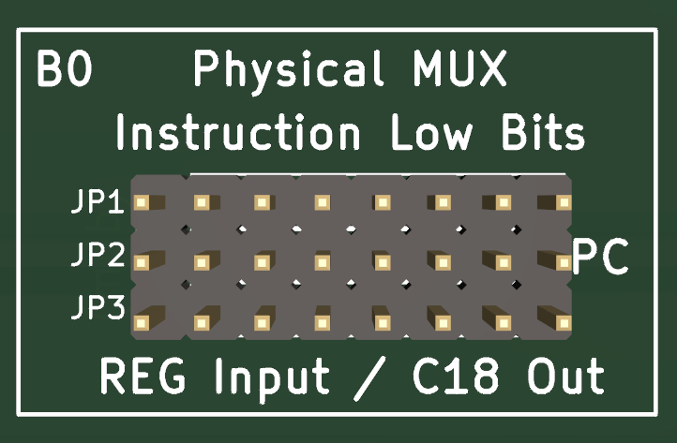

Figure 7 - B0 Physical MUX Pinout

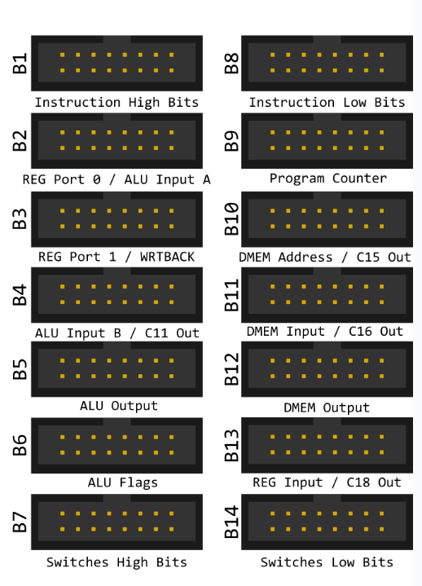

Figure 8 - B1-B14 Breakout Pins

Figure X shows the pin layout for both the headers on the ribbon cable. The ribbon cable header that has the 16P, attaches to the breadboards. The ribbon cable header that has the notch in the middle on the longest side for the PCB headers. Pin 0 is always on the side with the red wire.

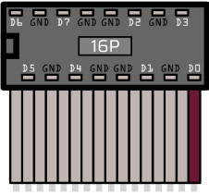

Figure 9 - Pin Layout for both i281e CPU and Bread Board Headers

Chart X below shows the Reference Designator, the labeled name on the CPU, and what its data path really means. Figure X below shows those paths more visually. Here you can follow the data path from and to components, so one could appropriately attach breadboards to the signals they desire. One could effectively remove one of the modules and use these headers to create a bread board version of the module and test it with the full system.

|  |  |  |
| --- | --- | --- |
| Reference Designator | Labeled Name | Meaning |
| B0 | REG Input / C18 Out | Data Path from Physical MUX to Program Counter |
| B1 | Instruction High Bits | Data Path from CMEM Instruction to Control Table |
| B2 | REG Port 0 / ALU Input A | Data path from REG Port 0 to ALU Input A |
| B3 | REG Port 1 / WRTBACK | Data path from REG Port 1 to WRTBACK module and C16 MUX Input 0 |
| B4 | ALU Input B / C11 Out | Data path from C11 MUX Output to ALU Input B |
| B5 | ALU Output | Data path from the ALU Output to C15 MUX Input 0 |
| B6 | ALU Flags | Data path from ALU Flags to Control Table |
| B7 | Switches High Bits | Dath path for the Switches High Bits to the Writeback Module |
| B8 | Instruction Low Bits | Data path from CMEM Instruction Low Bits to Physical MUX, C11 MUX Input 1, and C15 MUX Input 1 |
| B9 | Program Counter | Data path from Program Counter to CMEM |
| B10 | DMEM Address / C15 Out | Data path from the C15 MUX Output to the DMEM Address, C18 MUX Input 0, and CMEM |
| B11 | DMEM Input / C16 Out | Data path from C16 MUX Output to DMEM Input |
| B12 | DMEM Output | Data path from DMEM Output to C18 MUX Input 1 |
| B13 | REG Input / C18 Out | Data path from C18 MUX Output to Physical MUX and Register File |
| B14 | Switches Low Bits | Data path from Switches Low Bits to Writeback Module and to C16 MUX Input 1 |

Table 2 - Breakout Pins Explained

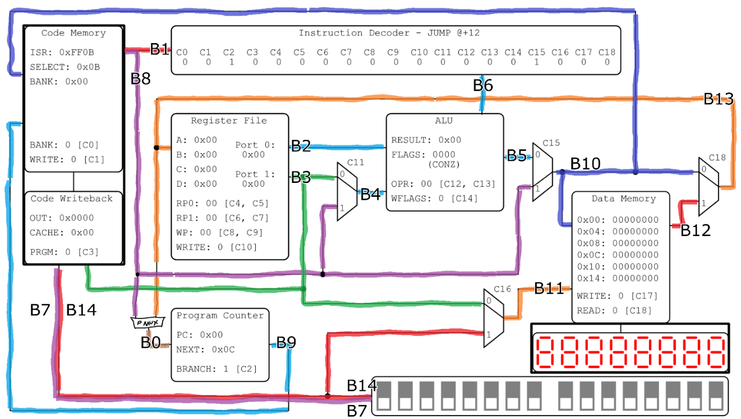

Figure 10 - Breakout Pins Data Paths Visualized

The i281e CPU also has pins that can be tapped to input the +5V rail, clock, reset, ground, and control signals to the bread boards. If the module that you are removing from the system requires a clock signal and reset signal, you can expect to tap all of the four signals on the left of Figure X. If the module also requires control signals 12, 13, and 14, you could use a wire to bring them from the CPU to the bread boards.

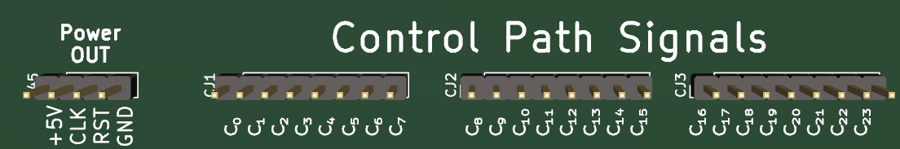

Figure 11 - Power and Control Line Output Headers

Figure X below, shows one of these tests. Here, we removed the C11 MUX, and replaced it with a breadboard MUX. We used the +5V and GND line from the “Power OUT” headers. Since it was thee C11 MUX, we used the C11 control signal. As for the 16-bit headers, we used B3, B4, and B8 which is the inputs and outputs of the C11 MUX.

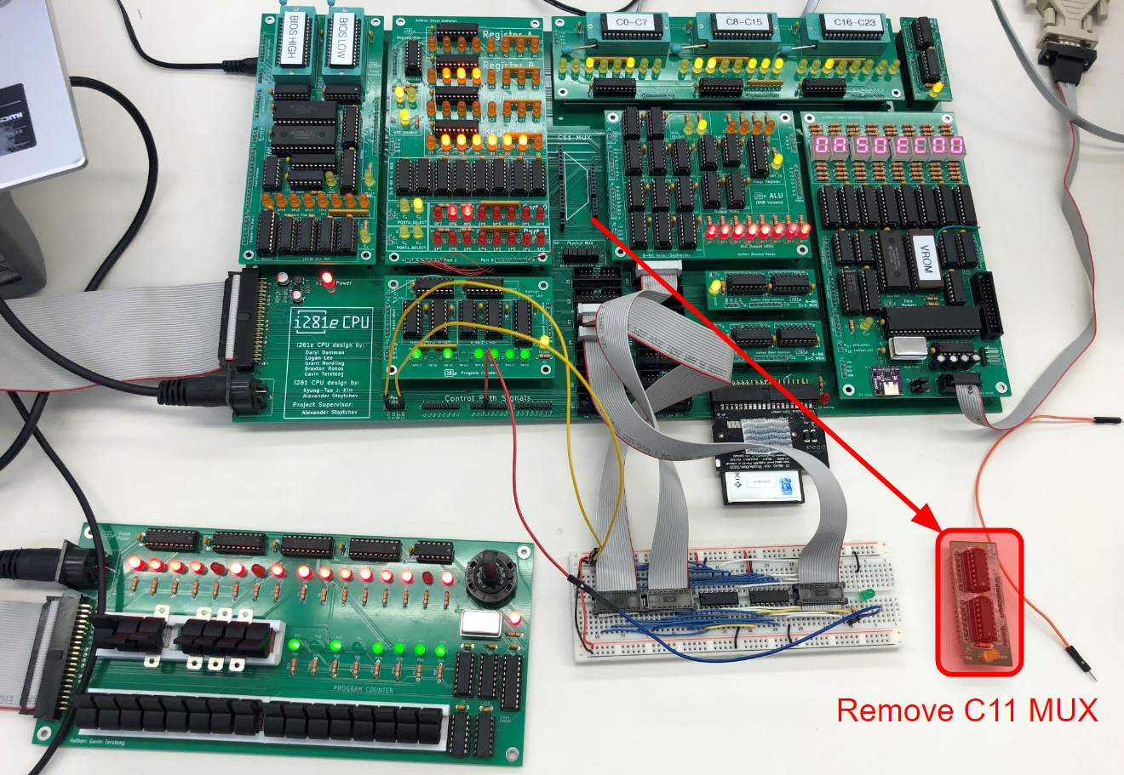

Figure 12 - Bread Board to PCB Implementation

## Running Programs

A terminal must be connected to the computer to load programs into RAM for running them on the i281e CPU. Tera terminal is a good option for communicating with the i281e CPU. Plugging in a USB cable to the USB-C port located on data memory and a computer with allow the user to see the DOS boot screen (DOS is explored more in later sections). To ensure the DOS functionality works, the process should run at maximum speed. After selecting the fasted clock frequency, toggle the reset switch and the i281e CPU will load the DOS menu.

The compact flash has different blocks for programs ready to run, from zero to nine. Use “CD” followed by a number to navigate to the corresponding block; for example, “CD 4” with allow the terminal to see into block four. Use “DIR” to list the programs stored in the corresponding block. This will print out a list of programs that can be called; by navigating with these commands, a program can be found. To run the program, type the block it is located in, semicolon, followed by the name of the program. For example, “4:BANNER” will run the banner.sv program from the fourth block of the compact flash.

A halt command can also called by using an ampersand symbol before “$4:BANNER”. This is helpful if the program needs a slower clock speed to be visible than the boot process. After calling the program with a halt command, the program loads into RAM like normal, but it will not start executing the RAM instructions after loading them. Instead, the i281e CPU will be in a loop in ROM. This loop can be exited after setting the clock to a lower frequency, by halting the i281e CPU and then using the examine switch. Simply toggle the switch with no switches active and the i281e CPU with start executing the program selected.

## Maintenace

### Finding Bad Parts

When the machine is not working as expected, it might not be the program that is being ran. There is a chance that a component overheated or something short circuited. If you smell something like plastic burning or see a plume of smoke, it is probable that a component burnt out. It is difficult to find the component when you are not sure where the smoke came from. Look for physical defects on all components such as burn marks, melted plastic, or misshaped components. Hover your hand over the board and feel for residual heat coming from components. If you see or feel anything from those components, chances are that those are the ones that got damaged. If you have access to a thermal camera, you can use it to see which components are getting hot when the i281e machine is on. This data can be useful to prevent the destruction of components.

Additional testing can be done via a multimeter or oscilloscope on components such as resistors, capacitors, transistors, and diodes. You can run a continuity test on them to see if they broke down into an open-circuit meaning that no current can flow through the components. You can also test to see if the parts are working as expected and have the properties that their datasheets say they should have.

One could also do some isolation testing. Remove modules from the board and individually test components and output pins. If a module does not act as it should, do more detailed testing on the individual components on that module. Once you find the issue parts, you need to switch them out for a new chip of the exact same part number, package size, and pin layout.

### Switching Out Parts

Throughout the life of the i281e machine, parts will become old, damaged, or simply breakdown. It is an occurrence that is simply bound to happen, so you need to know how to fix it. When a component isn’t working properly and it needs to be replaced, there are two methods that can be used: prying out the part or unsoldering components.

Prying out the part includes using a flathead screwdriver or some alternative object to get underneath a chip that sits in a dip package. From this, you can get leverage on the chip and pry it up. This method is used primarily for the 74HCT logic chips that are in the dip packages. From Figure X, we can see on the left, there is a logic chip in the dip package and on the left there is the part with the chip removed.

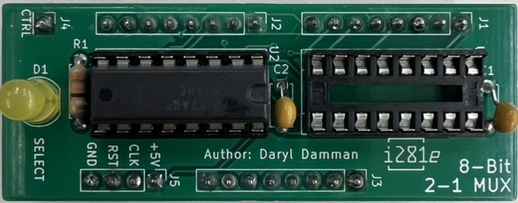

Figure 13 - Dip Package with and without Chips

Unsoldering components requires either a soldering wick or heat gun. To use the soldering wick, press the wick on top of the solder you wish to remove. Press your soldering iron into the wick at the same location as that solder. As the wick heats up, it will start to draw the solder into itself. If the solder is stubborn, add additional solder to the problem area and repeat the process of using the wick. Sometimes adding additional solder helps the wick absorb the solder.

If you have access to a heat gun, you can use that to unsolder several pins at once. This method is better suited for components with multiple pins or leads close to each other. The solder used on the PCB boards melts at around 700oF, so ensure that you set the heat gun to the right temperature. To remove components, aim the heat gun at the solder until it starts to shine like a mirror. At this point, the solder is in a liquid form. Use pliers to pull the component out of the other side. Repeat as necessary. Be careful not to aim the heat gun at yourself. Do not touch the component with your fingers as the component may be hot.

Once you have the component removed, you can install the new one. For parts that are inserted into the dip packages, firmly press the chip into the package. Ensure that the semicircle at the center of the dip package aligns with the semicircle on the chip. If the chip is not going in easily, use the pin adjuster or some pliers to make 90o angles on all of the pins pointing downwards. Then retry pressing the chip into the package.

For parts such as a resistor or LED, simply slot the part into the board. Then flip the board over onto the opposite side and find the location where the part is located. With your soldering iron, apply heat to the solder pad. The solder pad is a ring of silver colored material at the base of the through-hole connection. Once the solder pad is heated, press your solder into the pad and pin it until it melts. If you cannot get the solder to melt, put a dot of solder onto the tip of your soldering iron and try again. Once the solder is melted, it should attach to both the pad and the pin. If done correctly, the solder should take up the whole pad and not be rounded like a ball (See Solder Joints 1 and 3-7 on Figure X). If the pad can still be seen, reflow the solder and heat the pad until it covers the whole pad. If the solder is not visibly attached to the pad and pin all the way around the pin, add more solder until it covers the whole pad. Solder Joint 2 on Figure X, is lacking some solder. The joint should still function correctly but would be more reliable if there was more. If the solder joint looks like a ball, you have put too much solder on the joint (See Solder Joint 8 on Figure X). Consider applying a solder wick as discussed above to remove If the solder joint looks darkened, you applied too much heat and the flux in the solder is burned out. This type should still work but look for the issues mentioned previously.

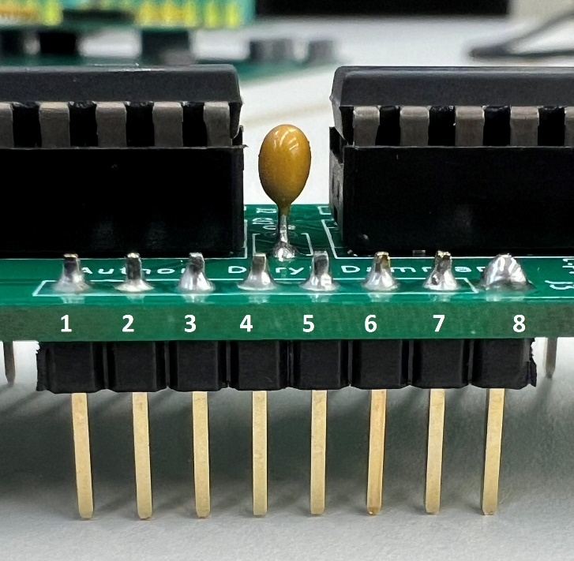

Figure 14 - Different Types of Solder Joints

## Expansion Capabilities

Since the i281e CPU works as a computer, there is a world of opportunities to expand the functionality of the design. Keeping this in mind, the i281e CPU hardware team thought ahead and left an 24-bit expansion bus and power bus on the bottom right side of the DMEM Module. This location allows for newly designed modules to be placed on the right side of the machine and connected. The signals that are sent out are the DMEM output bus, read & write lines, control lines C17 & C18, lower bits of the DMEM address line, clock, and demux select line using the DMEM address line. Figure X below shows the expansion bus and power outputs located on the bottom right side of the DMEM Module.

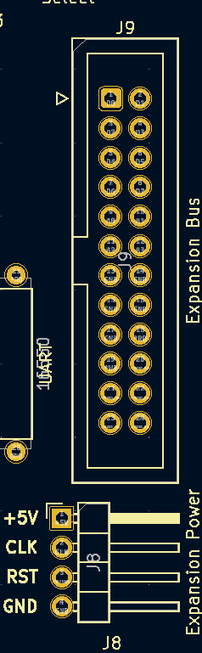

Figure 15 - Expansion Bus and Expansion Power

During the design and development of the i281e CPU, some of the group members created some passion projects to expand the project beyond the original requirements. One of these projects was the Mega I/O Expansion PCB card. This card allows the use of a printer, speakers, PS2 keyboard, and PS2 mouse. Figure X shows the card. This card barely scratches the surface of the expandability of the i281e CPU.

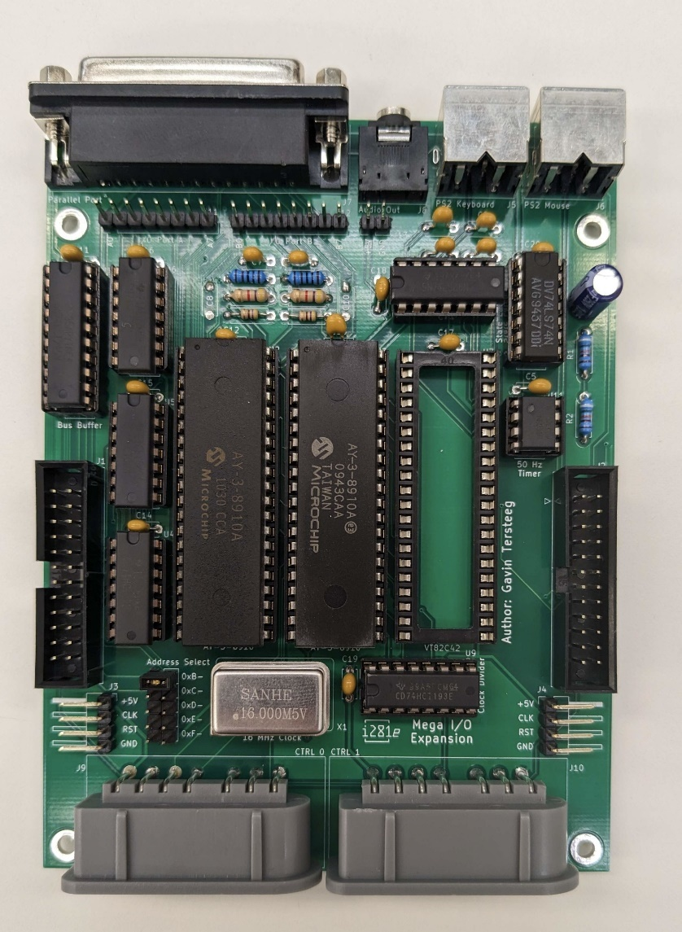

Figure 16 - Mega I/O Expansion Module

# Chapter 3: Processor Operation

Logical information for each board and component, etc.

## Code Memory

(This section should include information about the subcomponent “writeback module.”)

### Design Theory

To avoid issues with needing to modify or load a program in the same chip as the BIOS, a ROM and RAM chip will be distinguished. In addition to containing ROM and RAM, which holds the BIOS, Code Memory handles all interactions with program loading and execution. Instructions for running the user's program will be stored and executed from the RAM. This will be filled in with the necessary instructions during boot. Either the RAM will be filled from a storage chip on the device storing sample programs or filled using the switches manually (via BIOS loader).

The size of both ROM and RAM has been extended compared to the FPGA design. Since the code memory will not be implemented as a massive register file, the independent ROM and RAM chips will allow storage far beyond the processor’s general capabilities.

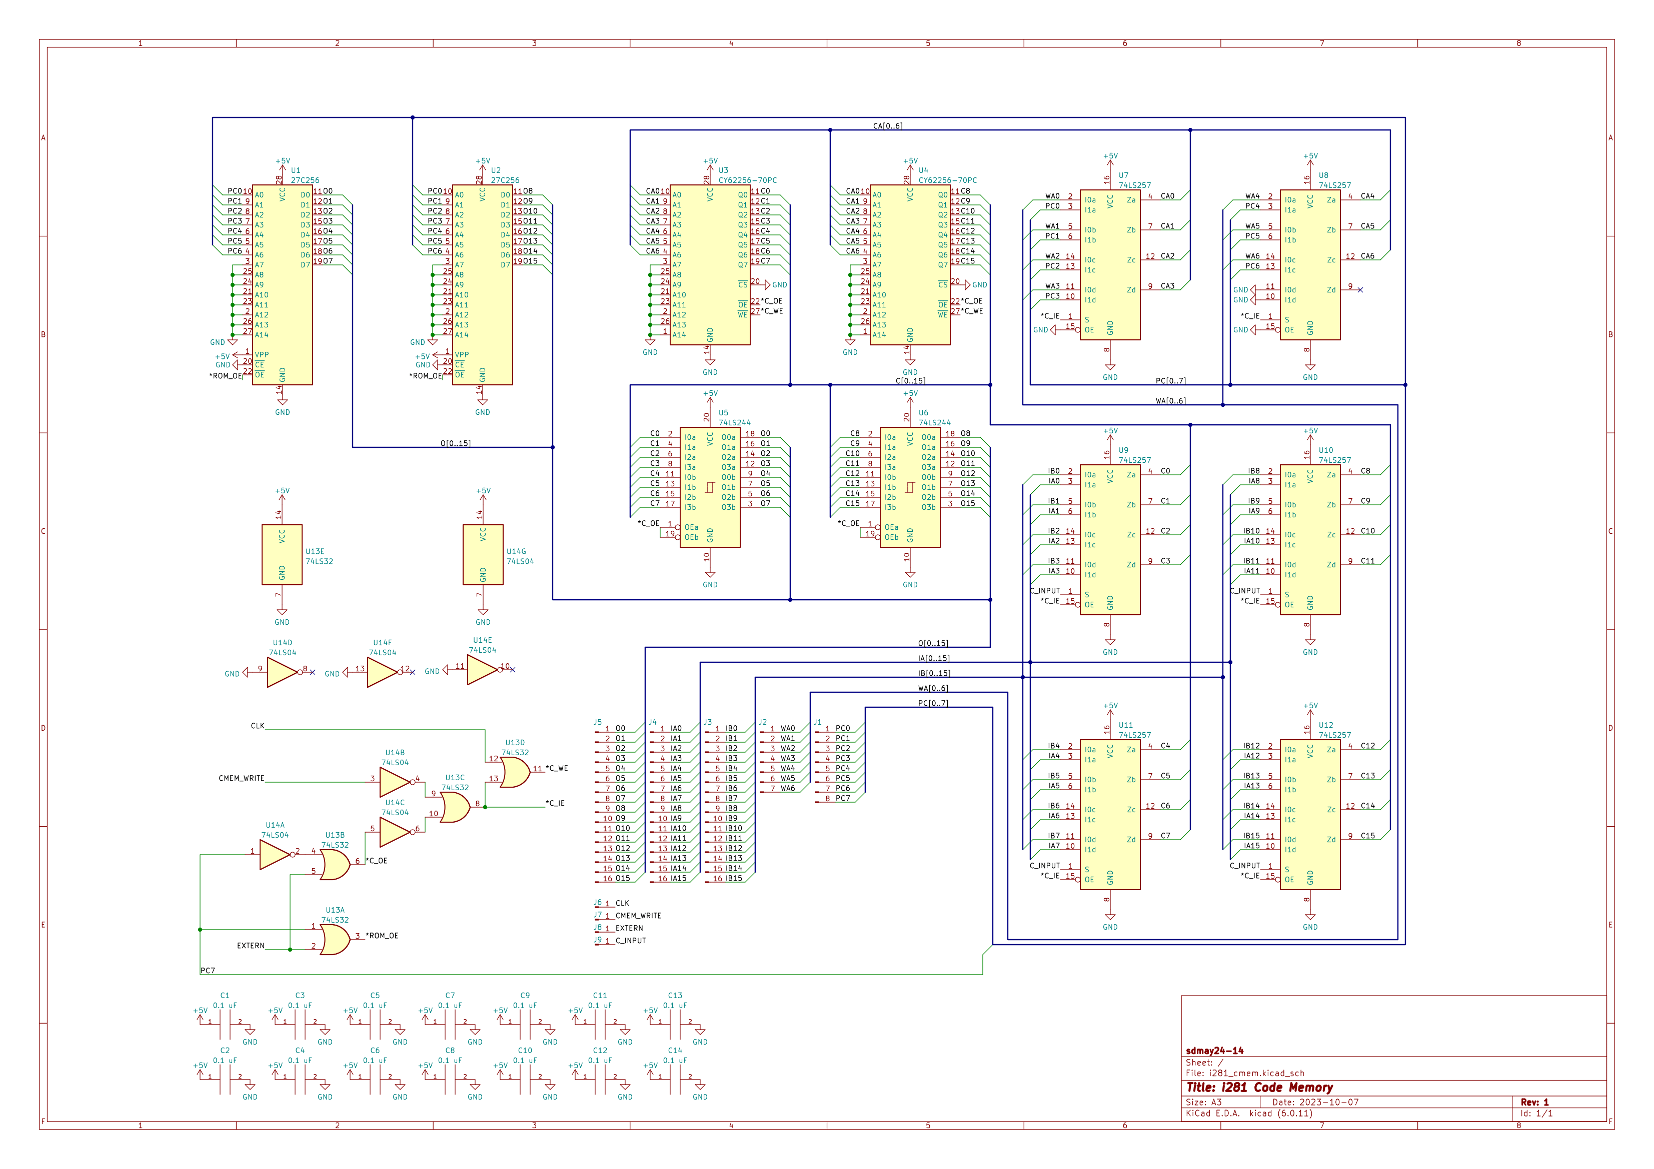

Figure 17 - Code Memory Schematic

### Design Theory

The code memory serves the main functionality of telling the rest of the i281e CPU what to do each clock cycle. This is achieved by outputting an instruction bus onto the 16-bit bus, depending on the program counter under normal operation.

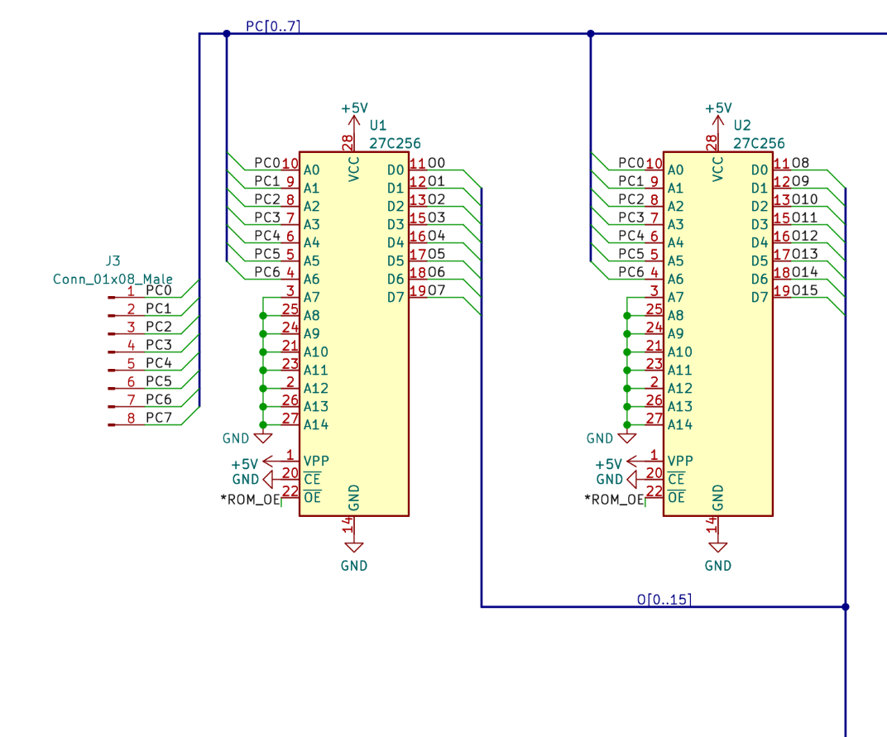

Figure 18 – ROM Chips

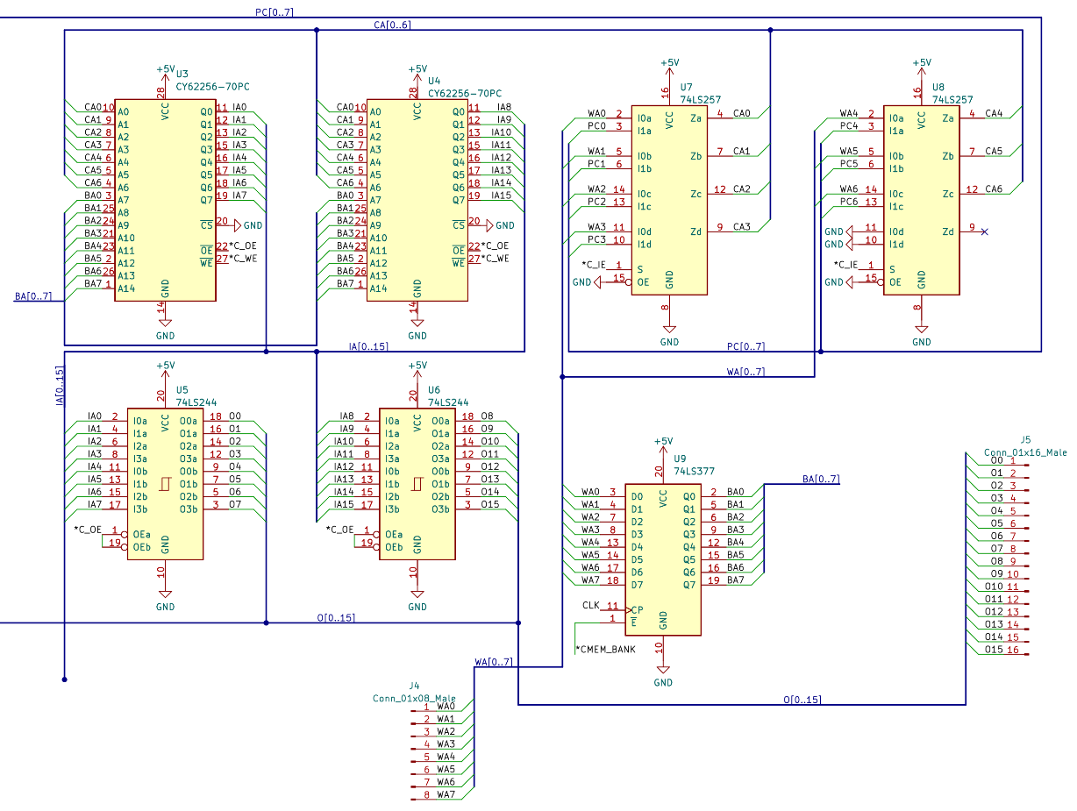

Figure 19 – RAM Chips with Additional Logic

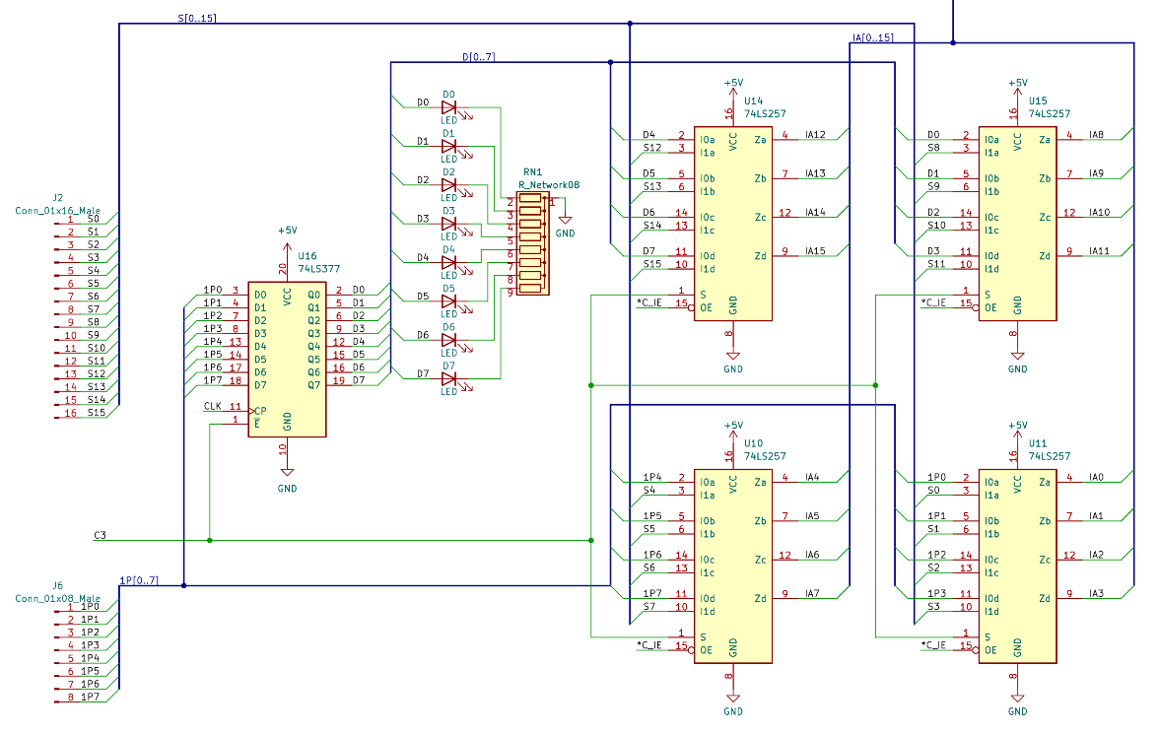

Figure 20 – Writeback Module

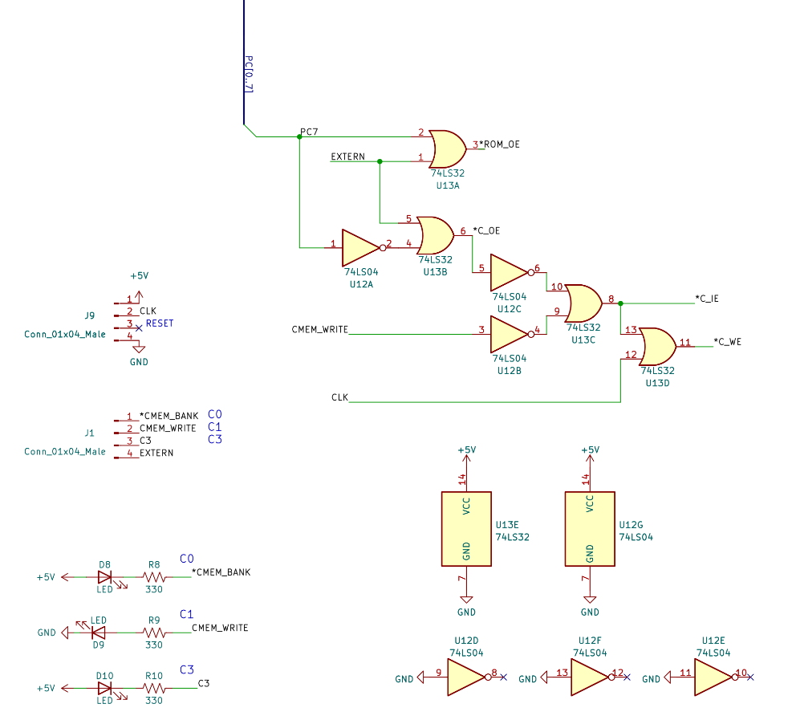

Figure 21 – Control Lines

### General Implementation

The code memory is built using 74-series logic chips of the HCT variety and ROM and RAM chips for data storage. Further, visualization must also be considered as there is no present way to observe the contents of the register. A full schematic of the register file can be found in Appendix A.

#### Inputs

The Code memory has many different inputs to achieve its goal of outputting an instruction line to the rest of the computer; many are used for debugging the i281e CPU and for initial setup.

The 16-bit bus is used for the switch input. This originates from the front panel. This bus is fed into eh writeback module of the code memory before being distributed to both an output buffer and RAM chips.

The 8-bit program counter is an input bus present here. This bus is routed to the ROM chips and through a mux to the RAM chips.

An 8-bit input bus is used for the write address bus. This is routed to the RAM chips through a mux and is used in setup when writing programs to the RAM. This bus originates from the C15 mux.

Another 8-bit mux is used to output port 1 from the register file. This is used in the writeback module and is vital to loading programs into RAM in setup.

The code memory also has 3 control lines used in the design and 1 special signal line from the code memory. These are used in the internal logic of the code memory, design when to write, and which output is active.

#### Visualization

An 8-bit LED visualization is used in the writeback back module on the code memory PCB. The saved bits are visualized since a register chip is used to save the inputs from port 1. These relate to the high bits of the instruction line being saved.

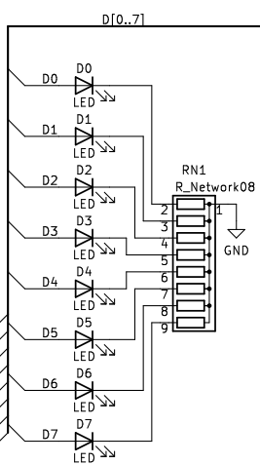

Figure 22 – Writeback Module LEDs

Each control line is also visualized in the code memory PCB. Since two of these are active low signals the LEDs are configured in a way to understand when the control line is being activated.

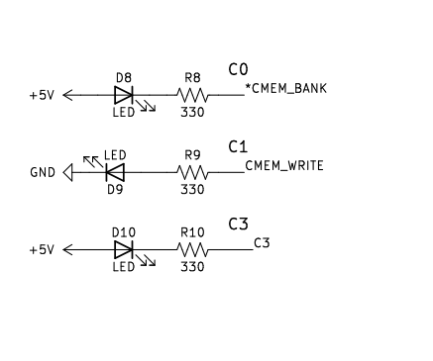

Figure 23 – Control Line LEDs

The code memory has a single output bus, a 16-bit bus carrying the instruction line for the rest of the i281e CPU. This bus has different chips able to outputting to this bus; however only one chip is ever active at once ensuring the current instruction line is read.

#### Outputs

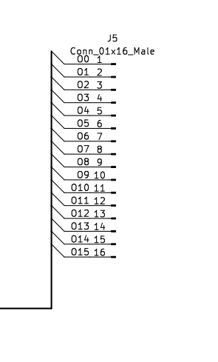

Figure 24 – Code Memory Output Bus

#### PCB Implementation

Converting code memory from the Verilog and simulator versions of the modules took major changes. Although the core functionality of the module stays the same, functionally to ensure it was compatible with the rest of the i281e CPU.

The BOIS chip was separated into two different chips, ROM and RAM. Functionality was added to write programs to the RAM chips, including the writeback module. Additionally logic was added to allow for the output bus was only ever controlled by one chip at a time.

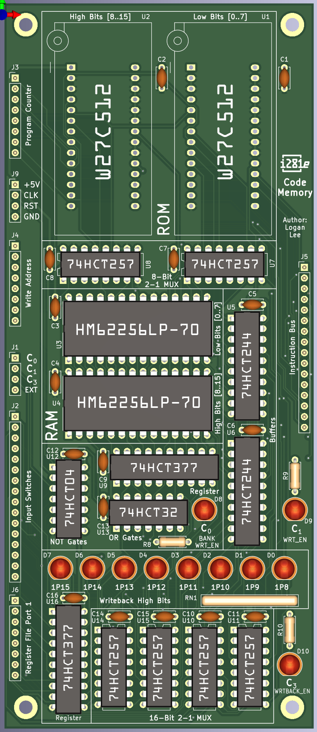

Figure 25 - PCB Implementation of the Code Memory (Rev. B)

## Register File

### Design Theory

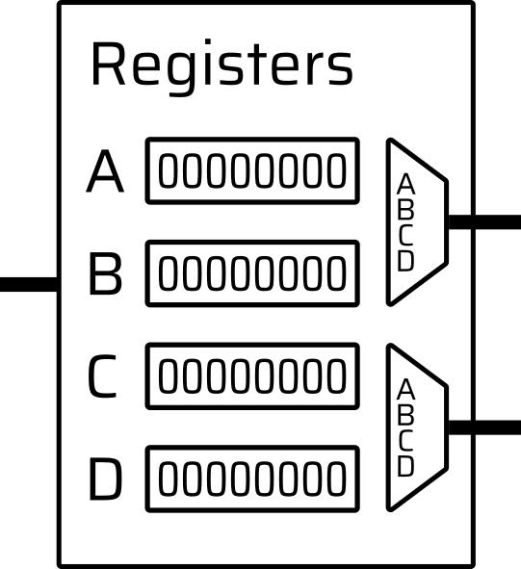

Figure 26 - Abstract register file representation.

The register file is responsible for handling intermediary data storage during processor runtime. Composed of four 8-bit registers, the intermediary data stored is used directly for the ALU, DMEM, or program counter (under select circumstances). These registers are composed of eight (8) D flip-flops in parallel with a write enable signal directing a multiplexer if the D flip-flops should accept a new input at clock pulse or use the pre-existing output.

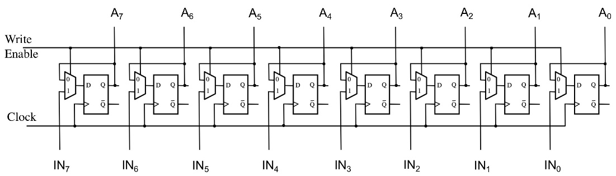

Figure 27 – 8-bit register using D flip-flops.

The registers are a fast memory solution, which can be found even in modern computers albeit in larger quantities than four (4) registers. The register file itself only takes in one data input but is controlled by seven (7) different control signals to dictate selection and writing. Additionally, the register file permits two registers to be read at a time utilizing the two output ports on the module.

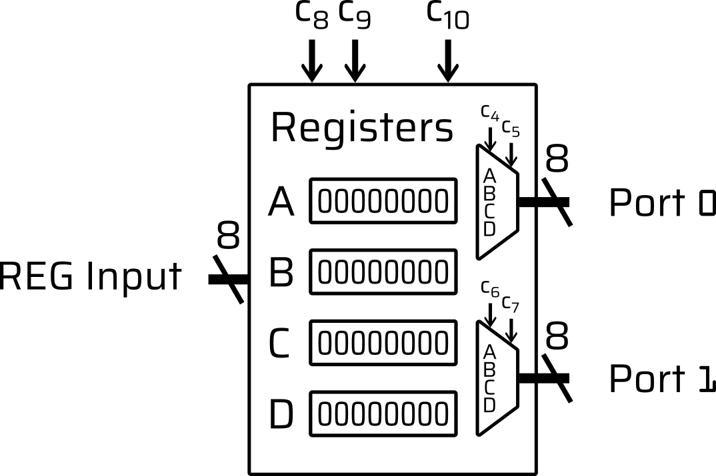

Figure 28 - Detailed abstraction of register file module

|  |  |  |
| --- | --- | --- |
| Control Signal Number | Control Signal Name | Active High? |
| C4 | Port 0 Select 1 | Yes |
| C5 | Port 0 Select 0 | Yes |
| C6 | Port 1 Select 1 | Yes |
| C7 | Port 1 Select 0 | Yes |
| C8 | Register Input Write Select 1 | Yes |
| C9 | Register Input Write Select 0 | Yes |
| C10 | Register Write Enable | No |

Table 3 - Control signal name table for the register file module

Taking in an 8-bit number, the register file will either ignore the input currently provided to the bus or propagate the data to the selected register if the write enable control line is asserted. This propagation occurs courtesy of signals; however, all 8-bit registers are wired to the input line for the register file. For writing to a register, control signals C8 and C9 are a 2-bit binary representation of the register letter alongside C10 as the write enable signal.

|  |  |
| --- | --- |
| Register Letter | Binary Representation |
| A | 00 |
| B | 01 |
| C | 10 |
| D | 11 |

Table 4 - Register letter representations in binary

Signals C8-10 could be joined together into a 3-to-8 decoder to determine which register, if any, will have their write enable signal asserted thus allowing the 8-bit registers to alter their contents at clock pulse.

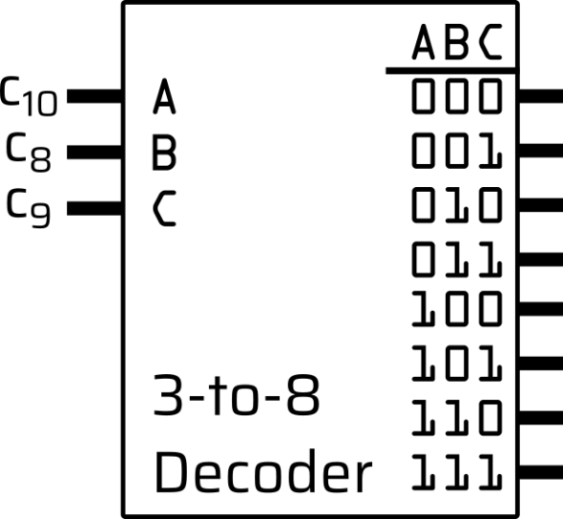

Figure 29 – 3-to-8 decoder using control signals of the register file

While in theory this works, the register file is directly implemented using C10 as an active low enable signal for a 2-to-4 decoder where C8 and C9 signals are the respective selection bits (see Table 3 - Register letter representations in binary), thus reducing unused connections (or pins).

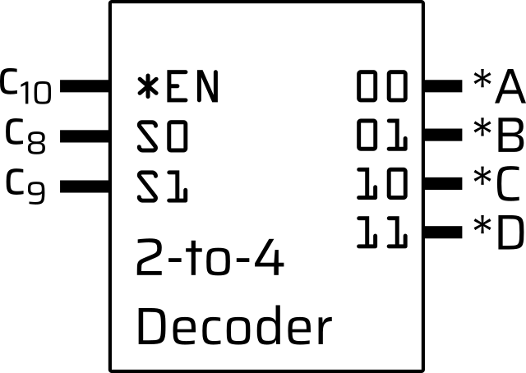

Figure 30 – 2-to-4 decoder with enable using control signals of the register file

The output of the registers, and consequently the output of the respective D flip-flops, is wired to both output ports of the register file. Given that there are four registers, not all registers can be represented at once through a single 8-bit data bus. For each port of the register file, an 8-bit 4-to-1 MUX is used.

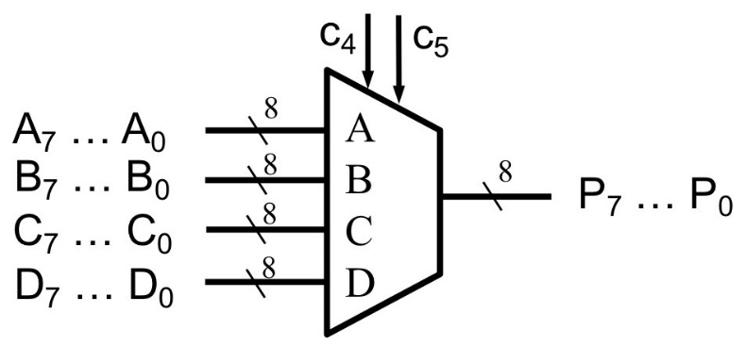

Figure 31 - 8-bit 4-to-1 MUX

Each port is assigned a set of control signals. Port 0 is assigned C4 and C5 whereas Port 1 is assigned C6 and C7 (see Table 2 - Control signal name table for the register file module). The 8-bit 4-to-1 MUX itself is built using 8 4-to-1 MUXs in parallel wired to the respective bit of each register.

### General Implementation

Like all modules of the i281e CPU, all discrete logic components are implemented using 74-series logic chips of the HCT variety. Further, visualization must also be considered as there is no present way to observe the contents of the register. A full schematic of the register file can be found in Appendix A.

#### Register Input

As noted in design theory, the 8-bit register input is directly mapped to all registers A through D. While each chip is not asserted on the enable line, the registers will not accept the continuous stream of data from the 8-bit input bus. Octal latch registers with active low enable (74HCT377) are used in-place of the 8-bit D flip-flop register configuration.

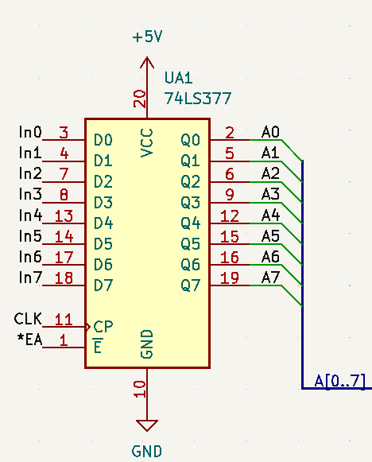

Figure 32 - Octal latch register with active low enable (Register A)

Selection for these registers is done using a 74HCT139 (Dual 2-to-4 decoder with active low enable) chip. Only one of the decoders on the chip is used. The output of each decoder line is then wired to the respective octal latch register.

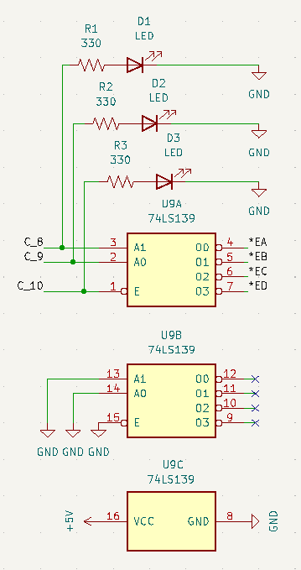

Figure 33 - Dual 2-to-4 decoder with active low enable and outputs

#### Visualization

There are 55 LEDs necessary to represent all signals and register contents within the register file alone. As shown with the 2-to-4 decoder, all LEDs are paired with a current limiting resistor of, typically, 330 Ohms. Each LED adheres to the visualization standards (see Appendix B) set by the i281e team. For the effort of compactness in PCB implementations, a resistor network is used for arrangements of 8-bit data.

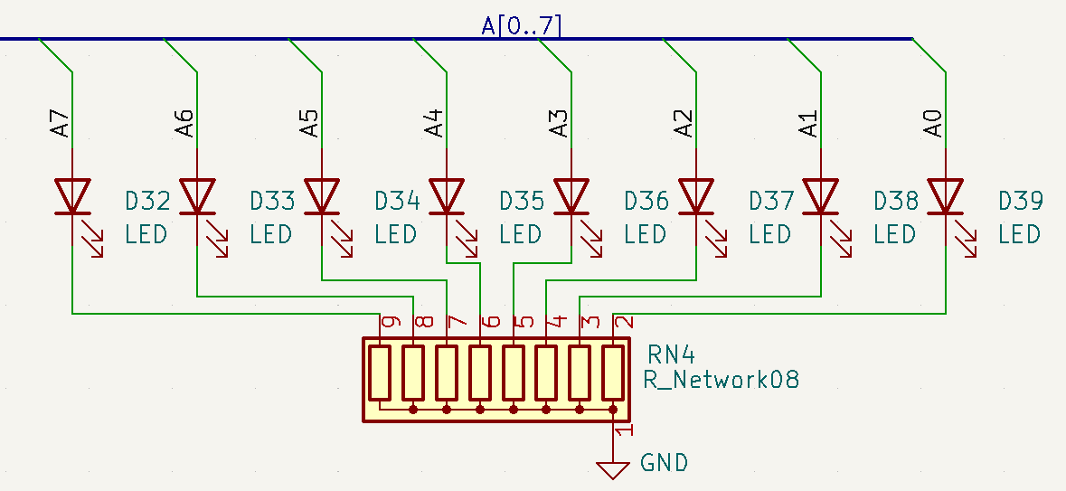

Figure 34 - 8-bit LED display with resistor network

These 8-bit data displays are used for the contents of Registers A through D and Port 0 and 1. The remaining LEDs are for the control lines and will have a single resistor paired with the respective LED.

#### Register Output

As seen by design theory, an 8-bit 4-to-1 MUX is constructed using multiple 4-to-1 MUXs. This is no different with using 74HCT253 (dual 4-to-1 multiplexer) chips. Each bit of every register is mapped to one 4-to-1 MUX.

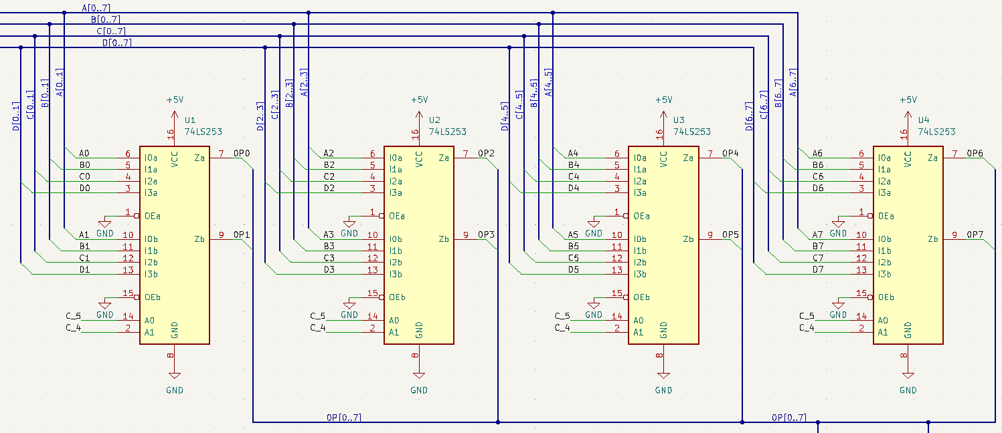

Figure 35 - Dual 4-to-1 MUX chips being used as an 8-bit 4-to-1 circuit (Port 0)

The respective control lines are still mapped to each 253 chip to select which register will be used. This is done for both output ports of the register file.

#### PCB Implementation

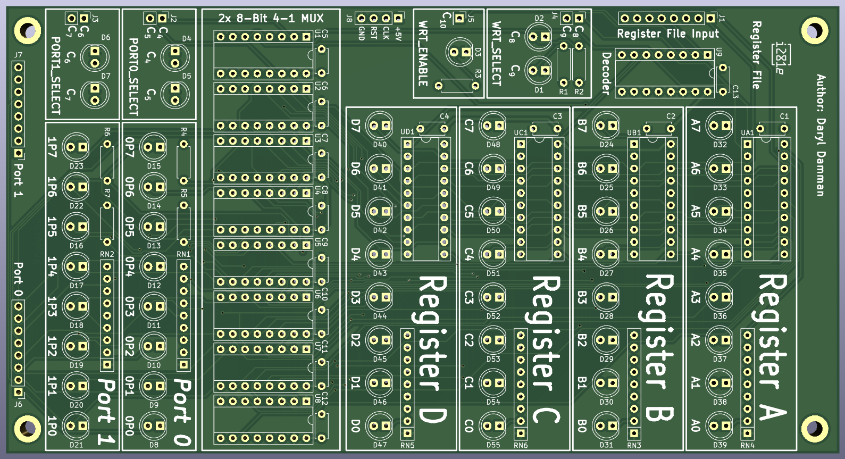

Figure 36 - PCB implementation of the register file (Revision A)

From schematic to PCB (or even breadboard) is relatively the same. The primary difference of the PCB implementation is the inclusion of pin header connections. These are used to interface the register file board to the main board. Details regarding how these connections work is included in the main board section.

## Arithmetic Logic Unit

### Design Theory

The Arithmetic Logic Unit (ALU) is the part of the CPU that does bitwise operations using data from the register files or the code memory. The design employs three control signals. Two of the control signals are labeled ALU_SELECT0 (C13) and ALU_SELECT1 (C12) in the picture and they determine the output of the ALU (the second picture shows the different combinations that lead to different opcodes). The third one is to control the flag register. This design will output one 8-bit bus (ALU_RESULT in the picture) and one 4-bit bus (the flag register outputs). The flag register outputs the carry, negative, overflow, and zero flag.

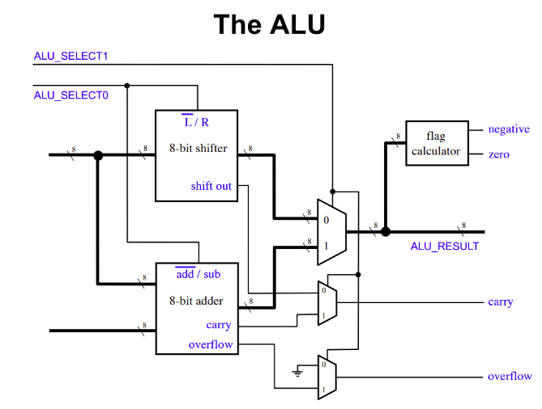

Figure 37 - ALU Subcomponents Diagram

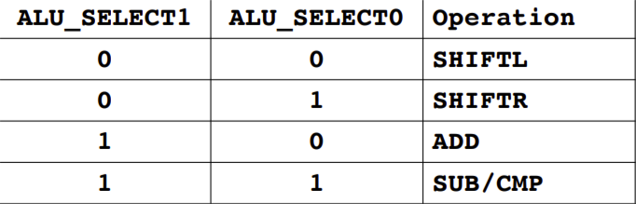

Figure 38 - ALU Arithmetic Mode Table

The 8-bit shifter circuit can shift a bit, either left or right. The ALU_SELECT0 control signal determines which way it goes. If ALU_SELECT0 equals a logic low, then the circuit shifts left and vice versa. The design itself can be seen below. This circuit shows the logic that shifts it both left and right depending on the select signal. This circuit has one extra output called Shift_Out which goes into a multiplexer in the higher-up circuit. It works as a carry flag when the ALU_SELECT1 control line is at a logic low.

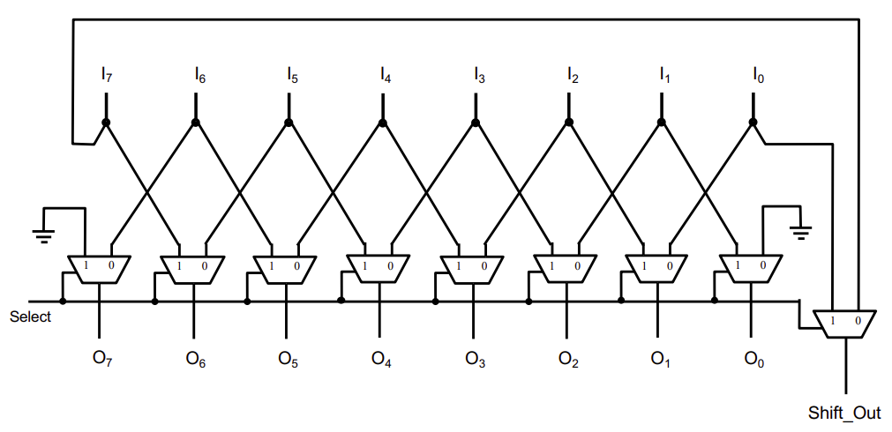

Figure 39 - ALU Shifter Design

The 8-bit adder/subtractor circuit is capable of both adding and subtracting two 8-bit numbers. When the ALU_SELECT0 control line is at a logic low, the circuit is in addition mode. When it is at a logic high, then it is in subtraction mode. This circuit is essentially eight full adders tied together in a line. This circuit also outputs a carry bit and a negative bit. All the output bits labeled S0-7 can be put into an 8-bit NOR to determine if the value is zero. If it is zero, it triggers the zero flag. Lastly, the C7 and C8 carry bits can be put into an XOR to show if the circuit has overflowed, meaning the result was too large to fit in the number of bits provided.

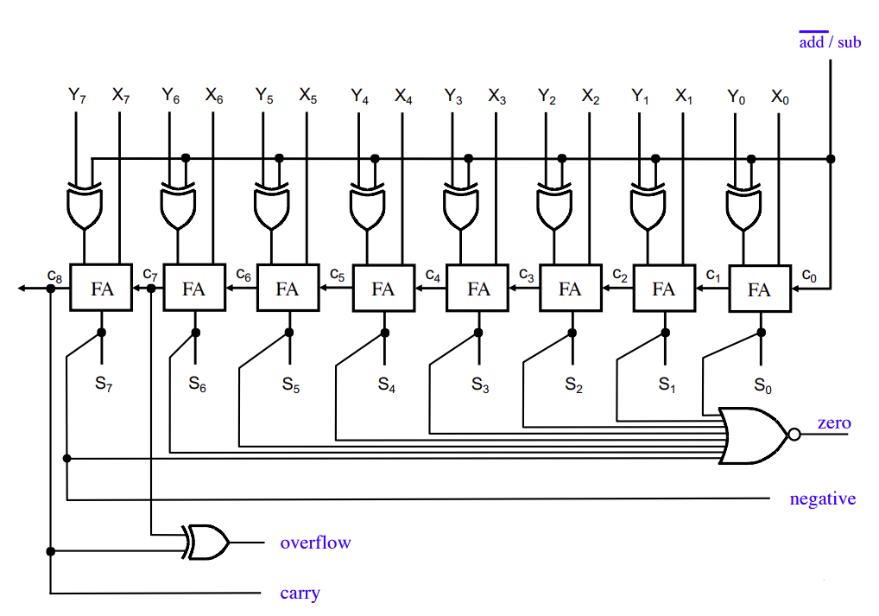

Figure 40 - ALU Addition/Subtraction Design with Flags

In addition to the original design, we created a secondary version of the ALU that removes the Shift Left operation and replaces it with a NOR operation. This NOR operation takes input from both input ports and simply NORs them together. Bit 0 from Input A and Input B NOR together and the rest follow suit. Below, we see the updated Mode Table and the graphical drawing of the NOR changes in the Shifter.

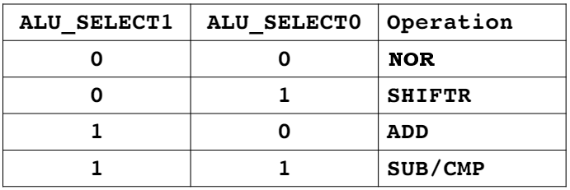

Figure 41 - ALU NOR Arithmetic Mode Table

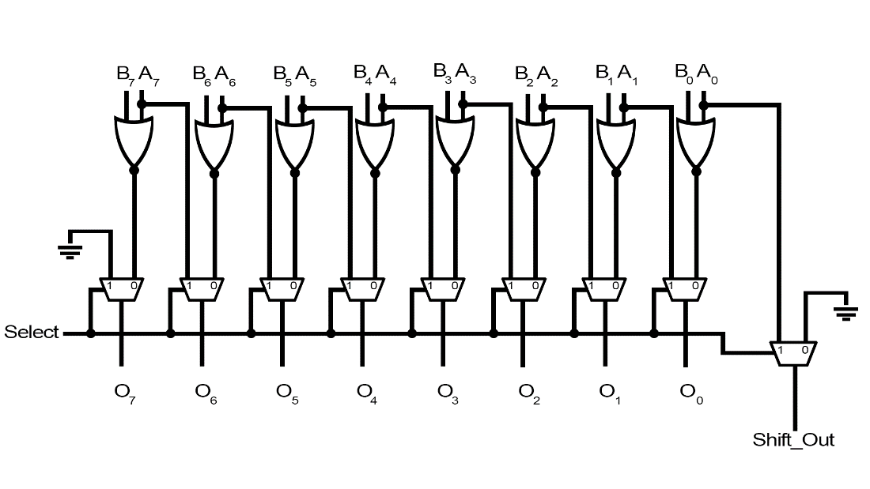

Figure 42 - ALU NOR Shifter

### General Implementation

The ALU uses 74-Series HCT chips to compute the logic. There are 4 different places for visualization to assist in showing the control flags, flag register bits, and output bits. These visualizations should help in understanding the functionality of the ALU. There are two separate PCBs and schematics for this design. One implements the Shift Left function and the other uses the NOR function.

#### Inputs

##### ALU Adder/Subtractor

The ALU takes the input bus from Port 0 of the Register Files (Input A) and the input bus from the C11 MUX (Input B). The C11 MUX takes input from Port 1 of the Register Files and the Code Memory. The signals of Input A and Input B go to both the shifter and adder circuits. The adder has the Input B signal enter the CD74HCT86E (Quad 2-bit XOR Chip) before it flows into the CD74HCT283E (4-Bit Adder Chip). There is an additional Adder Chip (U11) that receives similar input as the U6 Adder Chip. The U11 one is being used to flow out the carry bit that is in between output S2 and S3. Pins 11 (A3) and 12 (B3) on the chip are set to logic low and high respectively to let Pin 9 (COUT) have the same value as the carry bit prior. This bit is sent into U5, which is a another Quad 2-bit XOR Chip, used to calculate the overflow flag. The schematic below represents the adder and its signals.

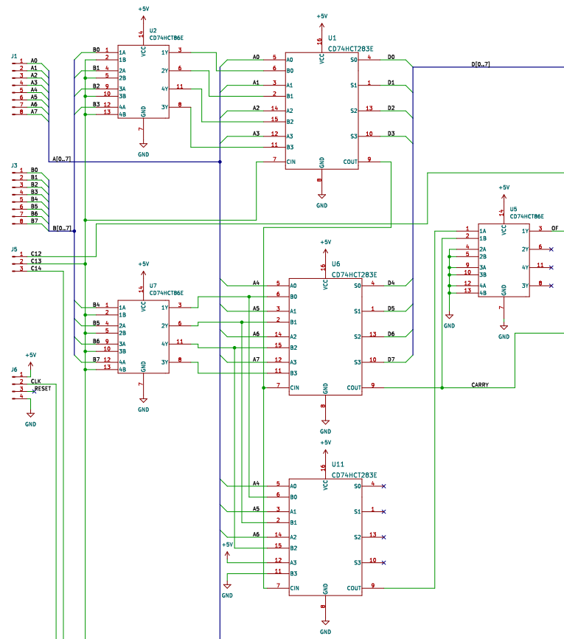

Figure 43 - ALU Schematic Addition/Subtraction Module

##### ALU Shifter

The ALU Shifter circuit requires three SN74HCT257N (Quad 2-to-1 Multiplexers) and only Input A. Reference Designators U12 and U13 shift the bits depending on Pin 1 (!A/B) for each of the chips and then outputs them into an internal bus. U14 is used to capture the bit that would be lost by this operation. Most of the pins are grounded since they are not used.

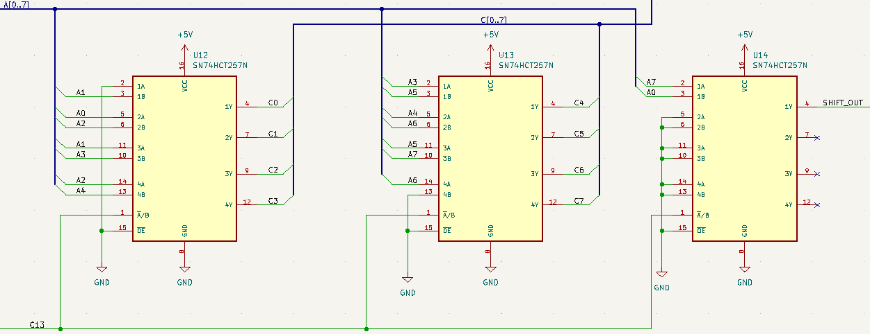

Figure 44 - ALU Schematic Shifter Module

##### ALU Shifter with NOR

In this version of the ALU Shifter, we added two CD74HCT02E (Quad 2-Bit NOR Chips). These chips take in both Input A and Input B. The output of those two chips goes directly into the two Quad 2-1 MUXs in the 0’s place or Pins A on the chip. Notice that on U16, the shift out MUX no longer has an input on Pin 2. This is due to the NOR functionality no longer shifting bits out, so it is grounded.

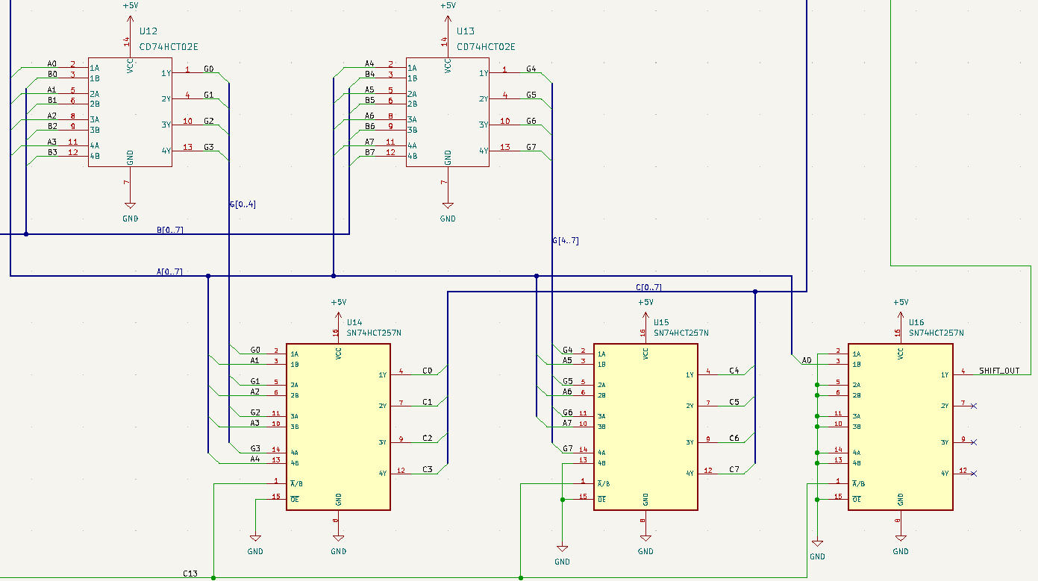

Figure 45 - ALU NOR Schematic Shifter Module

##### ALU Output and Flag Calculator

The top two SN74HCT257N chips are part of the output of the ALU. The bottom three chips SN74HCT257N, CD4078BE (8-Bit NOR), and CD74HCT377E (8-Bit Register File with enable). The ALU output simply takes output from either the shifter or adder circuit and sents it to the output bus. The value taken depends on the enable pin for both MUX’s which is connected to C12. The output signal goes straight into the C15 MUX. The U10 MUX chip calculates the Carry Flag and the Overflow flag. These feed directly into the U8 Register File chip. U9 calculates the zero flag and feeds into the Register File chip. The last flag is the negative flag and it comes directly from the 7th bit of the ALU output and that goes into the Register File chip too. After the Register File chip, the signals are sent to an output connector that feeds into the Control Table.

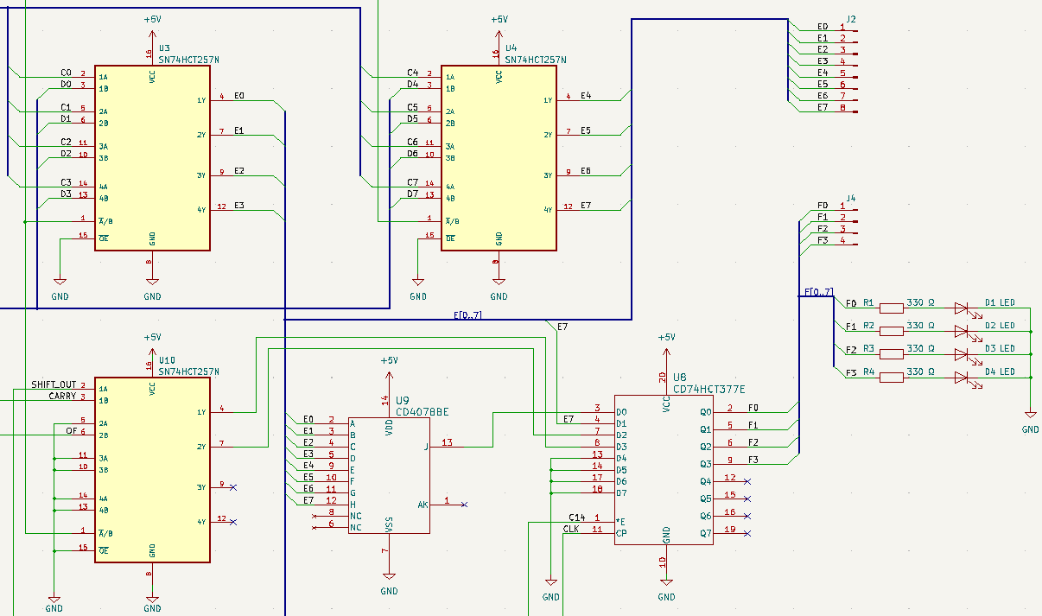

Figure 46 - ALU Schematic Output and Flag Calculator

#### Visualization

The control flags, ALU output, and flag registers are all visualized via different color LEDs. The Control Flags are yellow. The ALU output uses red LEDs. The flag register uses orange LEDs to visualize. The LEDs are ordered from least significant bit on the right to most significant on the left. The flag register LEDs are in the order from left to right: CF, OF, NF, and ZF.

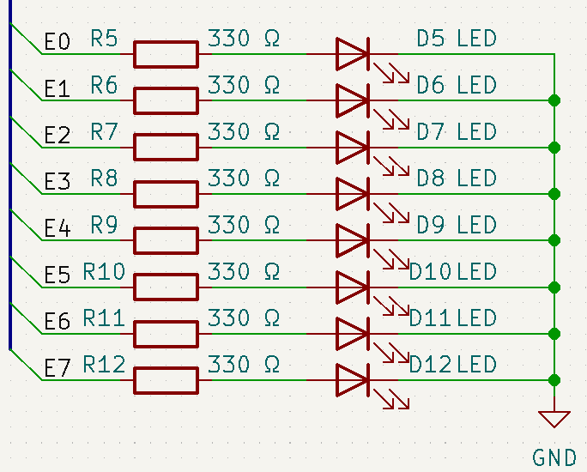

Figure 47 - ALU Output Visualization

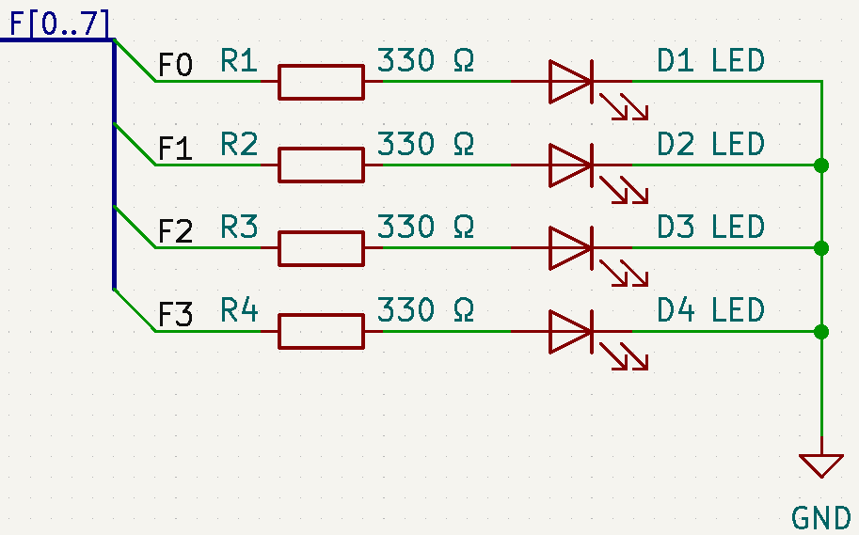

Figure 48 - ALU Flag Register Visualization

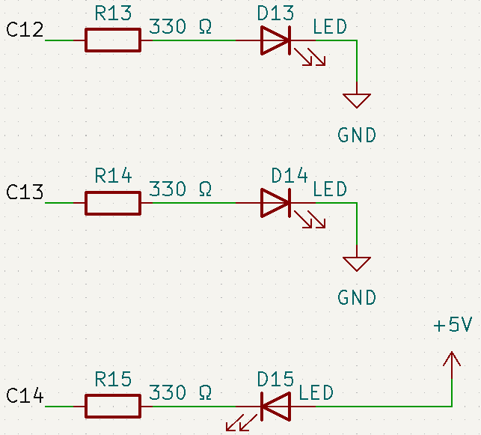

Figure 49 - ALU Control Line Visualization

#### PCB Implementation

For the PCB implementation, we used the schematic and turned it into a board. Everything is labeled in the module format as written about above. The input pins are on the left edge and the output pins are on the right edge. For the two different versions of the ALU, they have the exact same layout and labels except for the missing two chips on the original ALU. Both PCBs can fit in the same slot on the backboard and function as intended. Some adjustments may need to be made in the control table’s code to allow the different boards to work.

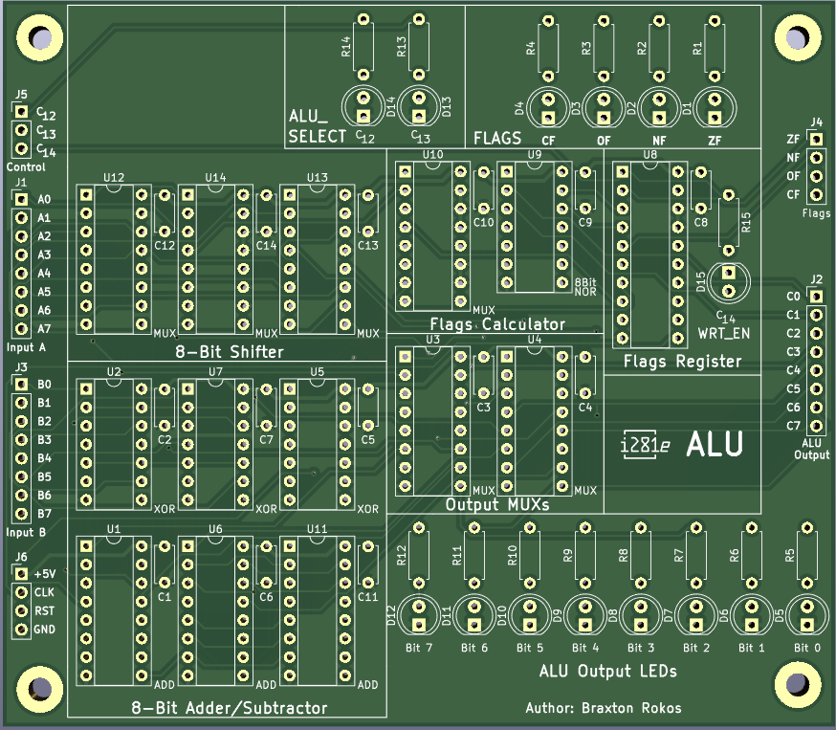

Figure 50 - ALU PCB

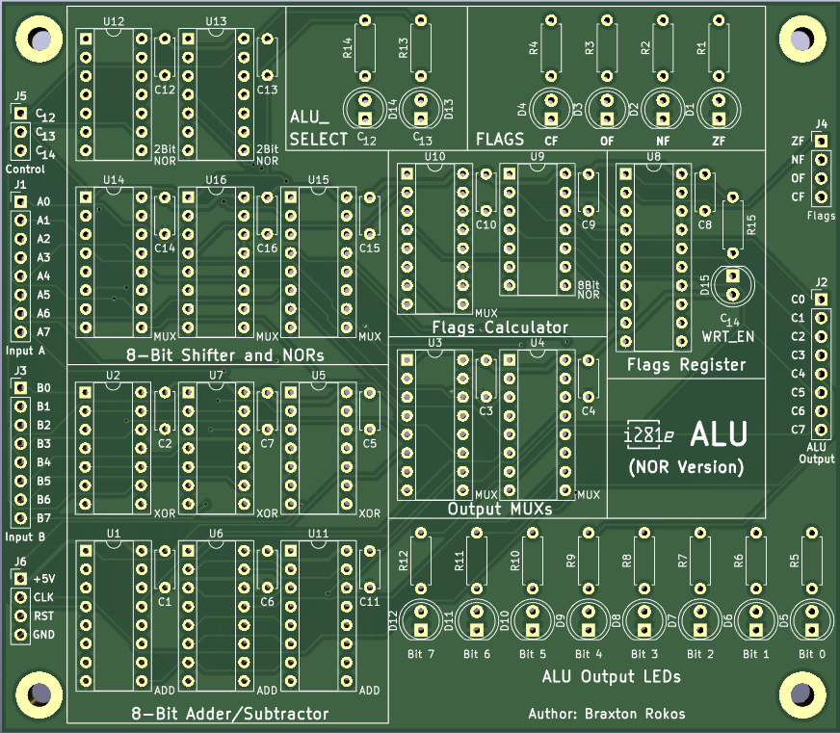

Figure 51 - ALU NOR PCB

## Program Counter

### Design Theory

The program counter (PC) is responsible for calculating the program counter's next value based on the program counter's current position. There are two options for the next program counter: the current program counter plus 1 or the current program counter plus 1 plus the input offset.

The logic of the Program counter is shown below. The current program counter is fed back into the 8-bit adder and increments by one. The second path of the program counter adds the offset bus to the incremented program counter value. There are now two options for the next program counter that are passed to the program counter mux. This mux, laying internal to the program counter, selects between two options using the control line, C2.

The register file responsible for holding the current value of the program counter will update with the next value, the output of the mux, whenever the clock pulses. There is no enable on this part, only a reset line that allows the computer to start at the being of the program.

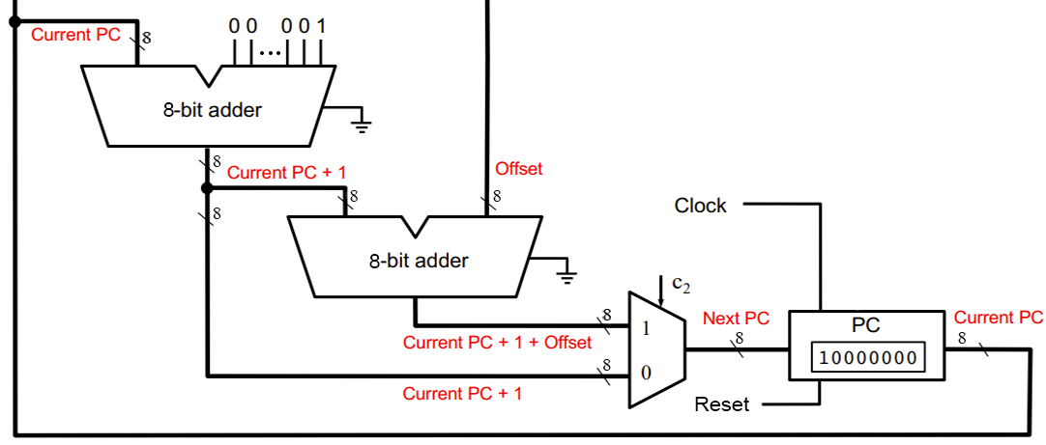

Figure 52 - Program Counter Logic

### General Implementation

The 8 bit program counter is responsible for holding the current value for the program counter and calculating the next value. This is completed by using 74 HCT series adder chips, mux chips, and a register file chip.

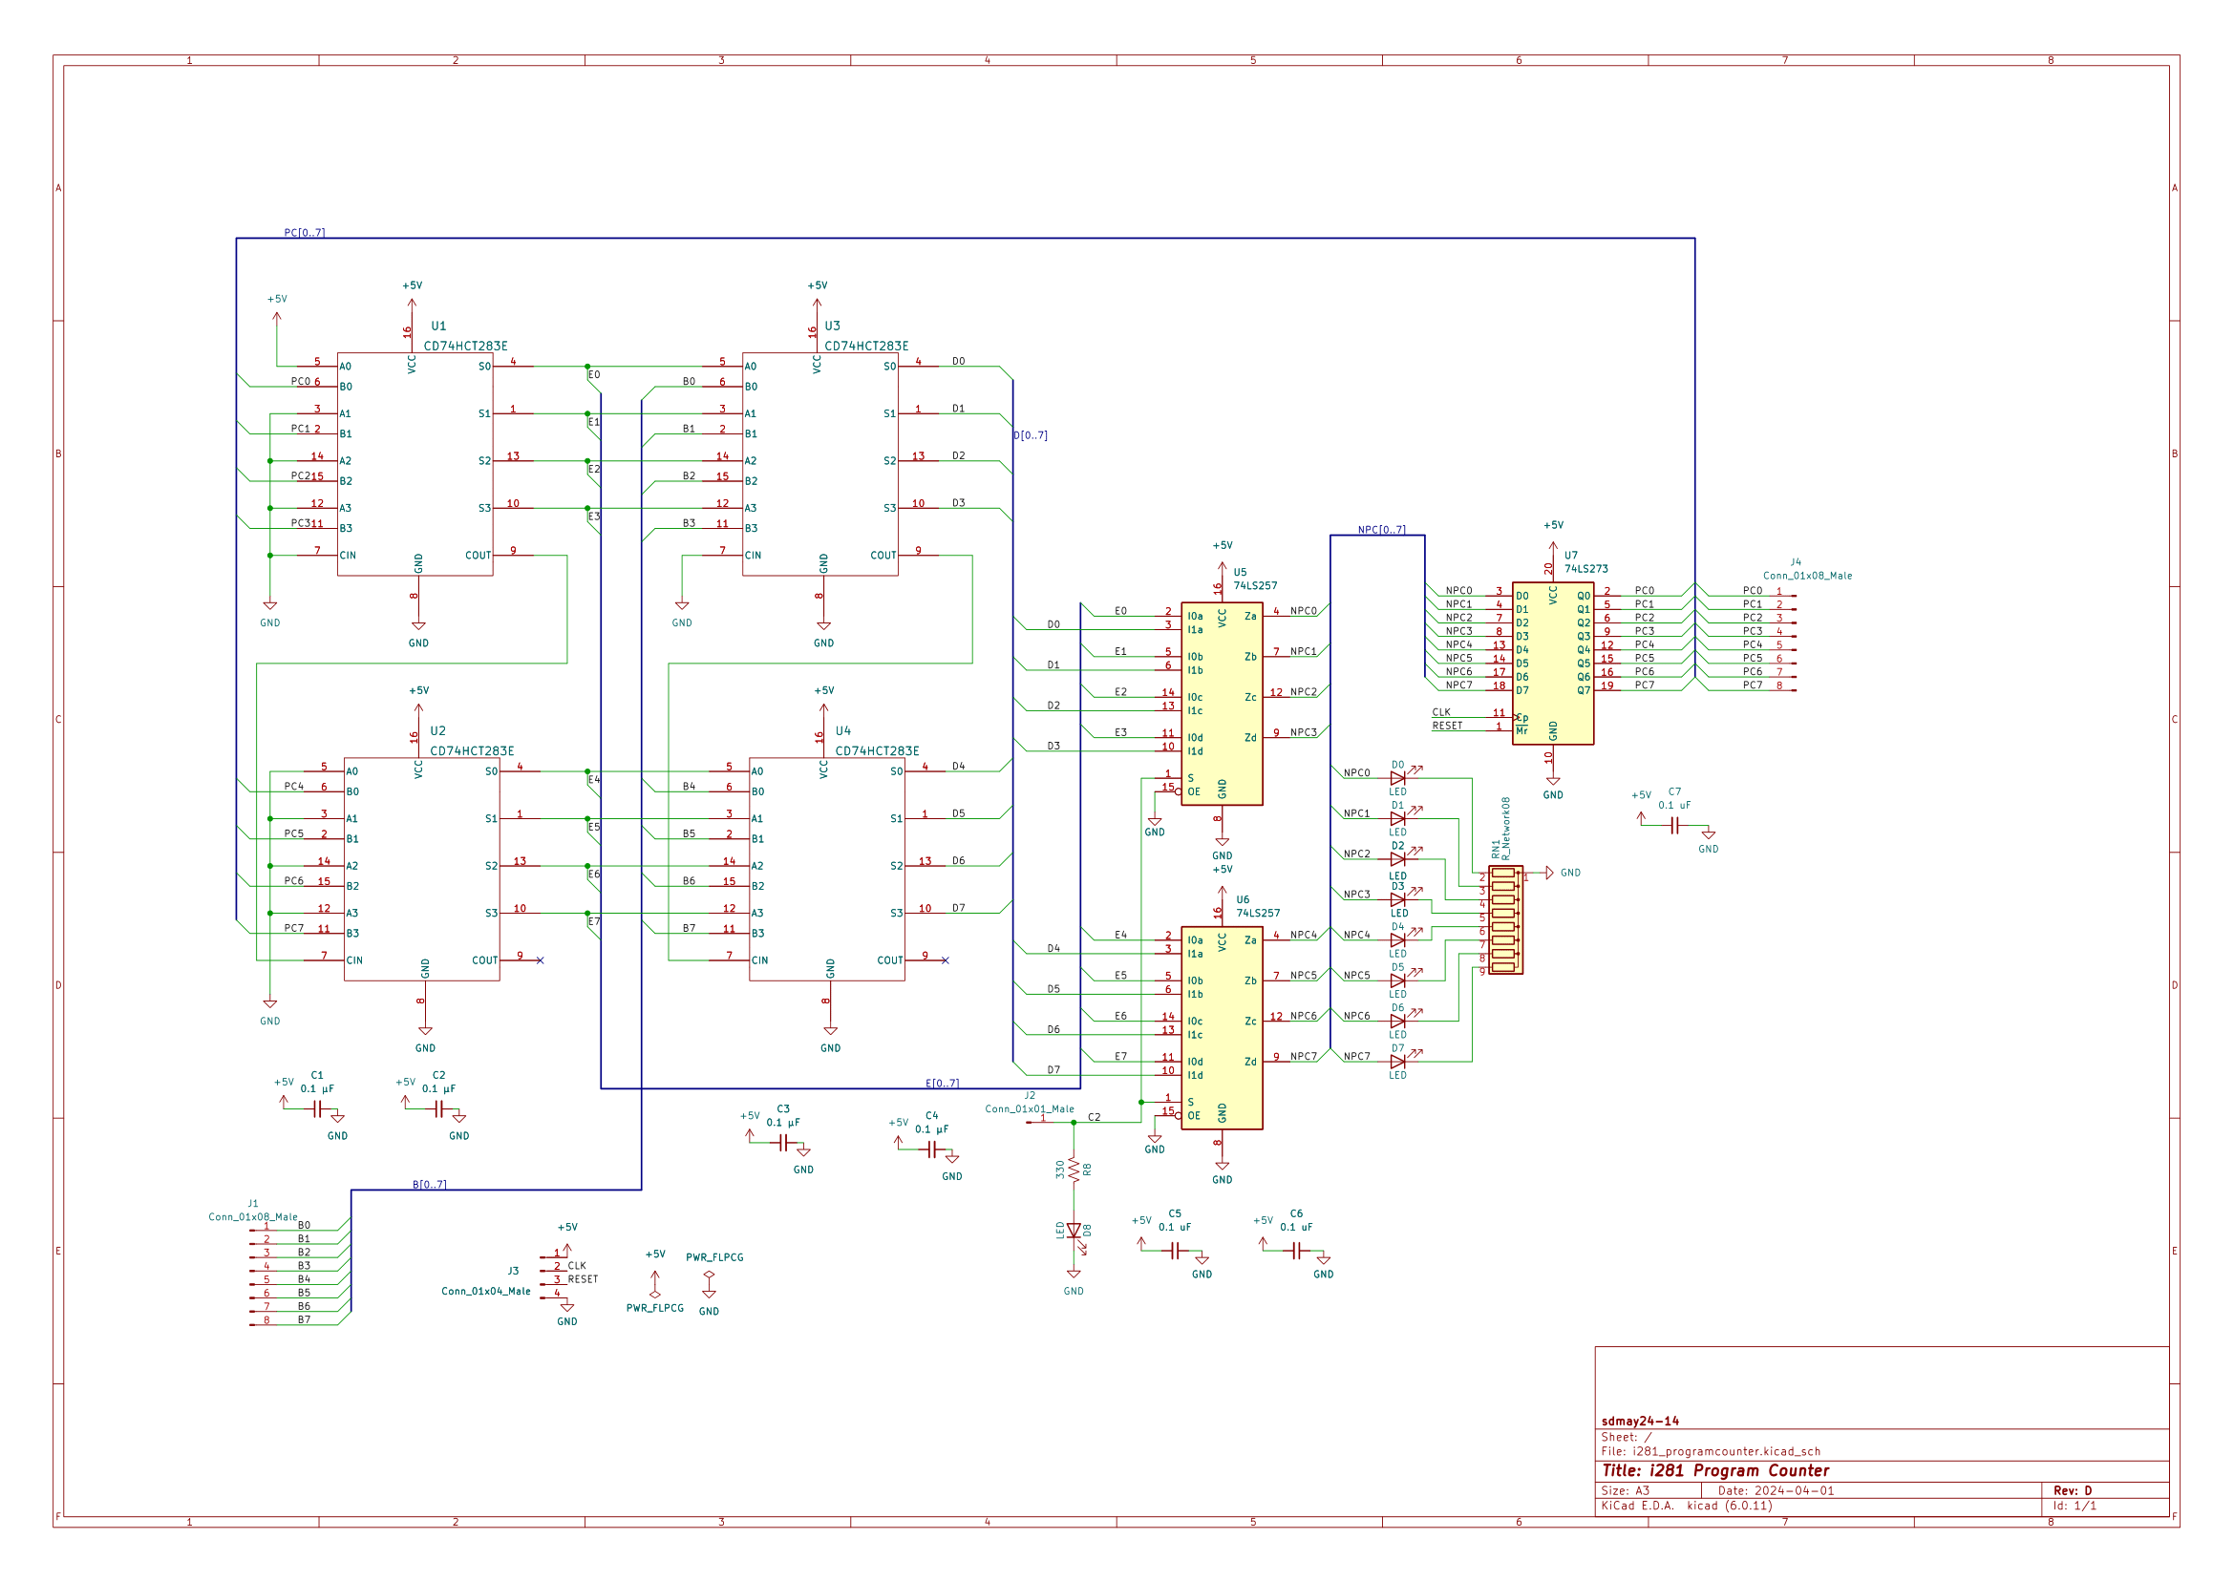

Figure 53 - Program Counter Schematic (Rev. B)

#### Inputs

The program counter has two input buses and a control line. The offset bus is the standard input bus seen on the physical boards. The other input bus is an internal input; since the program counter increments itself, the output bus is also routed back into inputs. The control line input, C2, selects the next program counter values using the PC mux.

#### Visualization

The value of the next program counter is visualized using 8 LEDs. This is the input to the register chip, allowing the user to see want the program counter will be upgraded to when the clock is pulsed.

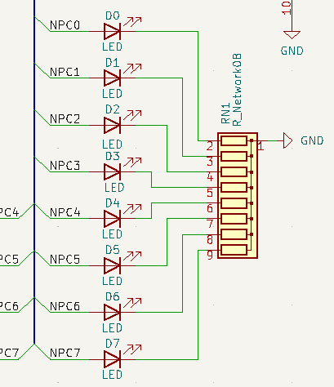

Figure 54 – Next Program Counter LEDs

The control line input is also visualized using a single LED. This allows the user to tell where the next program counter value’s is coming from, either incremented or offset bus.

#### Outputs

The output of the program counter is held in an 8-bit register, allowing it to have a constant value for an entire clock cycle. There is an external 8-bit bus that outputs this value as well.

#### PCB Implementation

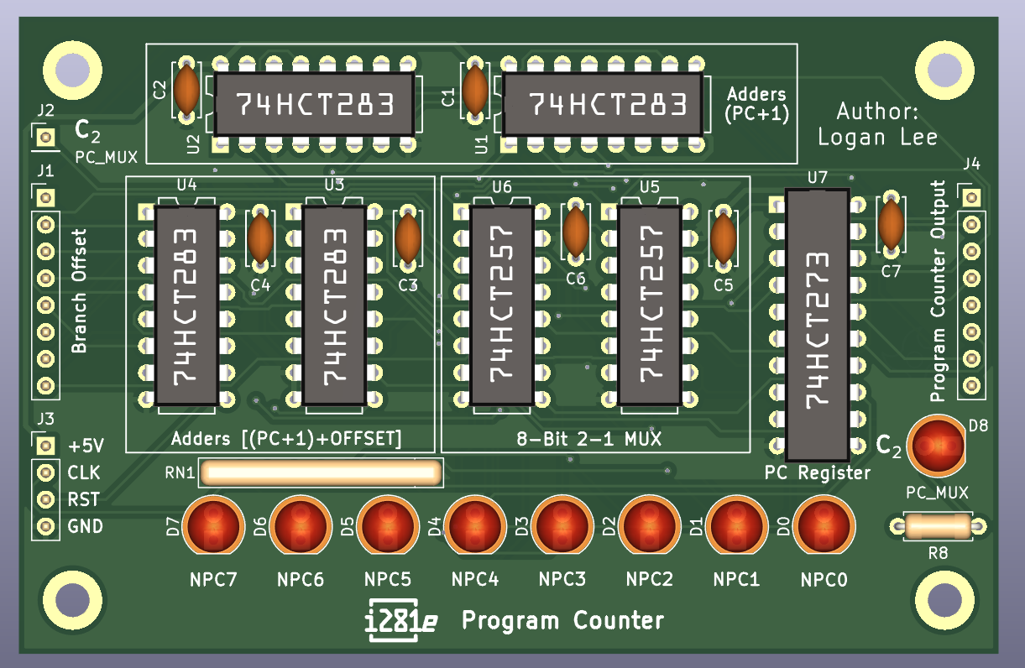

Figure 55 - PCB Implementation of the Program Counter (Rev. B)

The major changes when built in the PCB from the original Verilog and simulator version are the increase to 8 bits. The program counter also only has 1 control line used for PC mux instead of an enable for the PC register. The increase of bits allows for more instruction lines in the code memory and uses the same amount of chips as an original 6-bit version. The Program Counter is identical to the breadboard version.

## Data Memory

(This should also discuss the video card component)

## Control Table

### Design Theory

The control table, often referred to as simply the decoder, is an essential component for code operation in the i281e CPU. The control table reads input from a bus and decodes it to set data for almost every component in the machine. For most components, it edits properties of it or switches them on. Shown below is a table that outlines the inputs and outputs of the control table.

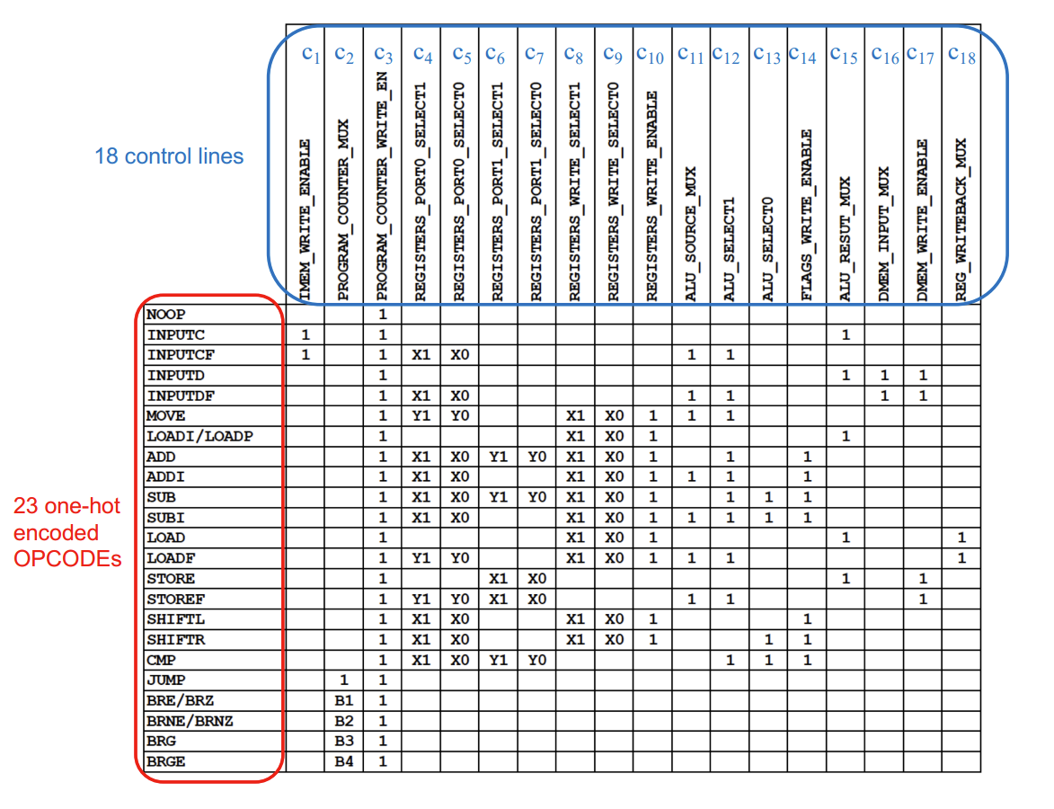Figure 56 - i281 original control table instructions

### General Implementation

To implement the control table in hardware, the control logic was changed to use EPROM to convert between the current operation and the control lines. The schematic for the design can be seen below. This simplifies the number of components in the design well, giving the same functionality. The EPROM is programmable, allowing the ability to update the control logic later.

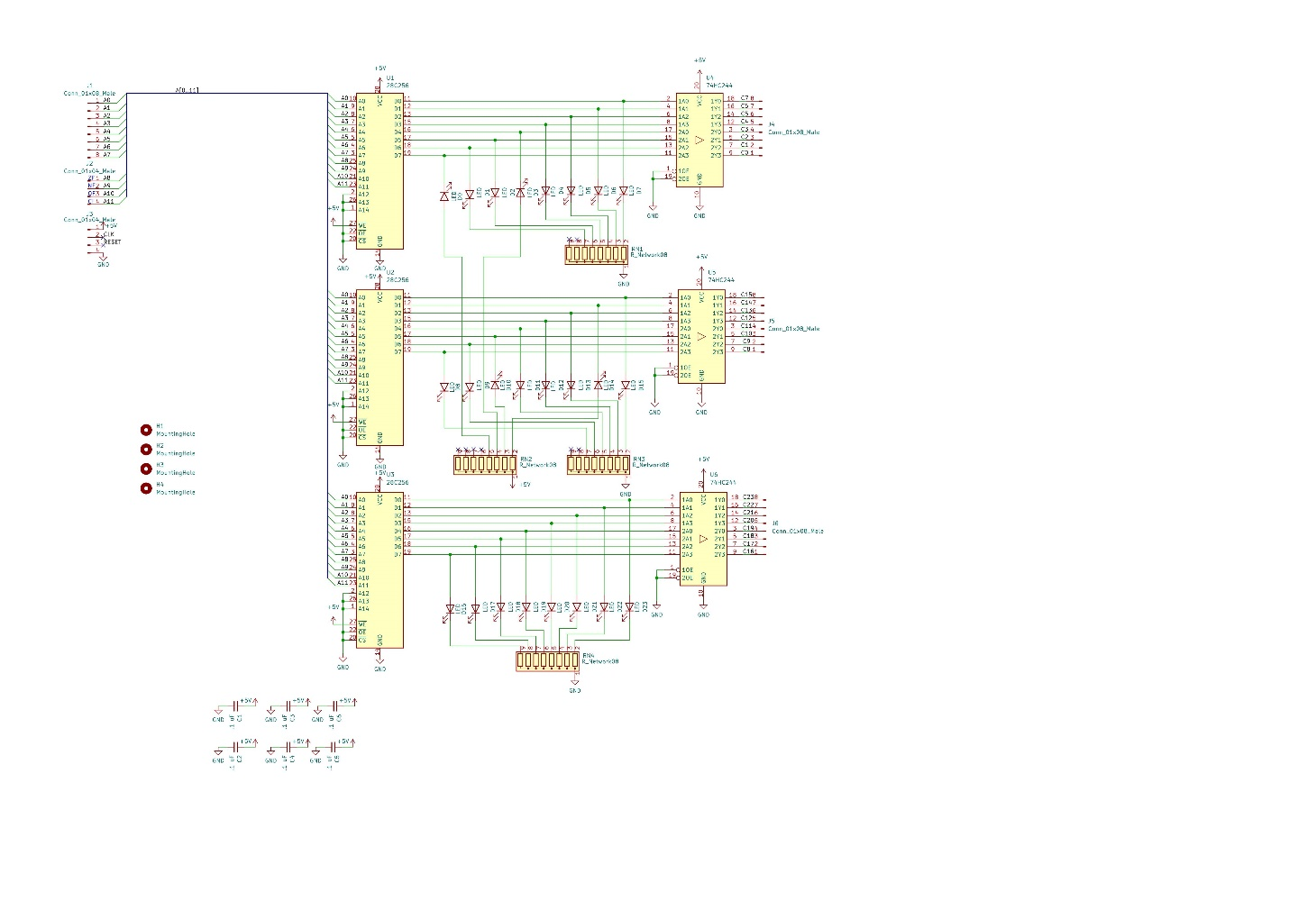

Figure 57 – Control table schematic

Since the CPU displays each control line's state at two locations, where it is generated and used, we are using a buffer chip. Each chip should only drive one LED, so this buffer is required to ensure proper voltage levels in the control lines.

#### Inputs

Inputs of the control table act as instructions. Each instruction is exactly 16 bits long. It is fetched, executed, and terminated in exactly one clock cycle. Not every instruction ends up using all 16 bits but keeping them at that length helps keep the i281e conceptually simple. An instruction can be broken up into two parts.

* **Opcode**: The highest 8 bits, which are sent to the control table and is used to generate the control signals for that instruction. This, along with the flag inputs, determines what the processor does during a specific clock cycle. The control table is the only part of the processor to receive the opcode.
* **Operand**: The lower 8 bits, which are sent to *C11* and *C15* to be used in the data path of the processor. The operand has no influence on what the control signals are during the instruction execution cycle. On the hardware, the value is known as the “Immediate Value.”

#### Visualization

The control table reaches throughout the CPU on all sides. It's not easy to display complete control lines on a PCB, but LEDs have been included to indicate the start and end points of control lines. The control line LEDs are yellow, and the data received at the destination matches the data that can be seen on the control table. Below is a summary of where the control table signals ultimately lead to.

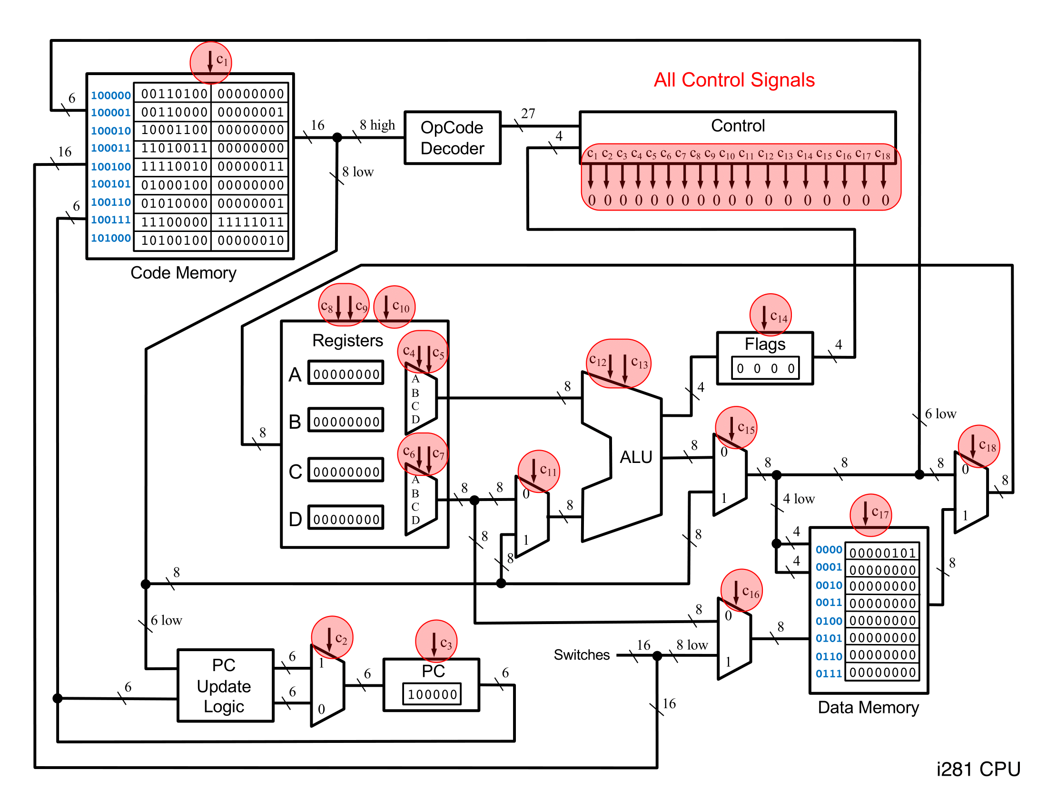Figure 58 – i281 Control Table Signal locations

#### Outputs

The outputs of the control table are the control signals that execute the instructions received as inputs. These control signals are generated based on the opcode, which constitutes the highest 8 bits of each 16-bit instruction. The opcode, along with flag inputs, determines the processor's actions during a clock cycle. This information is exclusively processed by the control table. However, the lower 8 bits of the instruction, known as the operand, are sent to C11 and C15 for use in the processor's data path. Unlike the opcode, the operand does not influence the generation of control signals during the instruction execution cycle but serves as the "Immediate Value" on the hardware.

#### PCB Implementation

A design was chosen to implement the control table in PCB, which closely resembles the original decoder in the i281 simulator. The data enters from the top, passes through the EPROMs and exits at the bottom after passing through the LEDs. Each chip drives eight bits of data, so the LEDs were spaced out to reflect this. However, there are some flipped bits in this design that are not visible unless observed closely. Therefore, during the debugging of the control table, it is essential to ensure that no bits are flipped to avoid any issues.

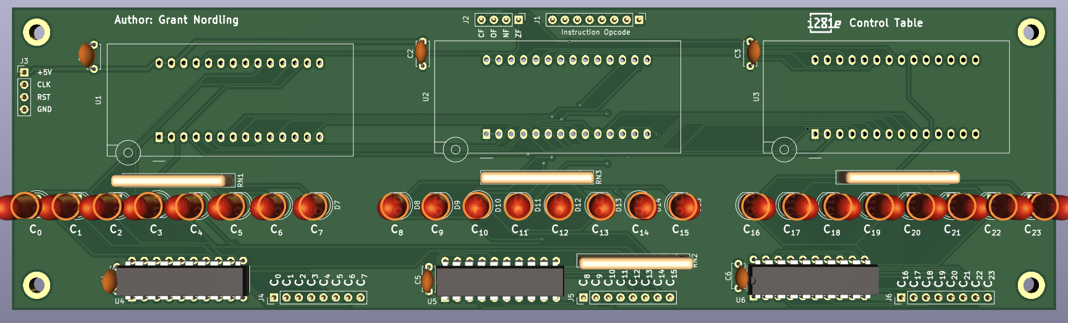FIgure 59 – Control Table PCB Implementation

## Mainboard

## Interface Panel

# Chapter 4: i281e Programming

# 4.1: Structure of an Instruction

Between different instruction set architectures, there is a wide diversity in how machine code instructions are encoded. Different processors employ a wide range of techniques to balance performance, memory consumption, and technical limitations. Some, like the MIPS processor, try to make instruction formats as simple as possible to reduce decoding times. Others, like the x86 family of processors, include a wide variety of valid instructions to make the most of each execution cycle. A modern x86-64 processor can execute 981 unique instructions, ranging from one to fifteen bytes long.

The i281e does not come close to that in terms of complexity. Each instruction is exactly 16 bits long. It is fetched, executed, and terminated in exactly one clock cycle. Not every instruction ends up using all 16 bits but keeping them at that length helps keep the i281e conceptually simple. An instruction can be broken up into two parts.

* **Opcode**: The highest 8 bits, which are sent to the control table and is used to generate the control signals for that instruction. This, along with the flag inputs, determines what the processor does during a specific clock cycle. The control table is the only part of the processor to receive the opcode.
* **Operand**: The lower 8 bits, which are sent to *C11* and *C15* to be used in the data path of the processor. The operand has no influence on what the control signals are during the instruction execution cycle. On the hardware, the value is known as the “Immediate Value.”

The opcode itself can be broken up further. The top 4 bits of the opcode

determine what “group” of instruction executes. Groups are a vague category that lump similar instruction together to ease decoding logic complexity. Some instruction groups contain several similar functions, while most contain only one. The bottom 4 are used as arguments to augment the function of that instruction further.

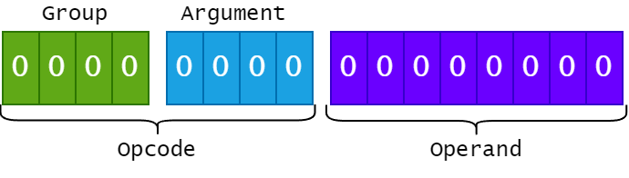

Fig 4.1.1: Basic structure of an i281e instruction

# 4.2: Instruction Functions

Since the opcode field that defines the group of the instruction is 4 bits wide, that means we can have up to 16 distinct instruction groupings. As mentioned before, these groupings only exist to make designing the decoding logic easier. Technically any combination of bits in the opcode can be encoded to do any function. However, it is easier for the hardware designers as well as the programmers if the instructions have some sort of patterns to them. The 16

opcode groups are:

* **0x**: Bank Instructions
* **1x**: Code Memory Write Instructions
* **2x**: Move Instructions
* **3x**: Load Immediate Instructions
* **4x**: Add Register Instructions
* **5x**: Add Immediate Instructions
* **6x**: Subtract Register Instructions
* **7x**: Subtract Immediate Instructions
* **8x**: Data Memory Load Instructions
* **9x**: Register Data Memory Load Instructions
* **Ax**: Data Memory Store Instructions
* **Bx**: Register Data Memory Store Instructions
* **Cx**: Single Value Logical Instructions
* **Dx**: Compare Register Instructions
* **Ex**: Unused
* **Fx**: Branch Instructions

Each of the 16 possible opcode groups can have 16 sub-instructions defined by the 4 bits of the argument. This gives us a total of 256 different instructions that the i281 can execute. Referring to instructions by their opcode number can get confusing fast, so we will give instructions names

depending on what function they perform. These instruction names, or more commonly known as “mnemonics,” give the programmer an idea of the function and syntax of the operation. The i281e has 37 instruction mnemonics by default. These are:

MOVE RX, RY / NOOP

Opcode:

|  |  |  |  |  |  |  |  |  |
| --- | --- | --- | --- | --- | --- | --- | --- | --- |
|  | 0 | 0 | 1 | 0 | R | X | R | Y |

Group: **2x**

Updates Flags: No

Function:

Moves the value stored in register *RY* (Registers are defined by 2 bits, with the numbers 0-3 corresponding with registers *A*-*D* respectively) into the register *RX*. The operand must be 0 or else an unintended addition will be performed on the value.

The *NOOP* instruction is an alias for a move instruction where *RX == RY*. In this case, there is no change in state for the processor.

LOADI RX, *

Opcode:

|  |  |  |  |  |  |  |  |  |
| --- | --- | --- | --- | --- | --- | --- | --- | --- |
|  | 0 | 0 | 1 | 1 | R | X | 0 | 0 |

Group: **3x**

Updates Flags: No

Function:

Moves the value in the instruction operand into register *RX*. In the instruction mnemonic, the character “*” represents the value of the operand. The instruction “*LOADI A,25*” would have an operand of 25.

ADD RX, RY / SHIFTL RX

Opcode:

|  |  |  |  |  |  |  |  |  |
| --- | --- | --- | --- | --- | --- | --- | --- | --- |
|  | 0 | 1 | 0 | 0 | R | X | R | Y |

Group: **4x**

Updates Flags: Yes

Function:

Adds the value of register *RY* to the value of register *RX*. The result is then stored in register *RX*. The alias *SHIFTL* *RX* is the same as *ADD RX, RX*. This is because shifting a value left once is the same as multiplying it by 2, which itself is the same as adding a value to itself.

ADDI RX, *

Opcode:

|  |  |  |  |  |  |  |  |  |
| --- | --- | --- | --- | --- | --- | --- | --- | --- |
|  | 0 | 1 | 0 | 1 | R | X | 0 | 0 |

Group: **5x**

Updates Flags: Yes

Function:

Adds the value of the operand to the value of register *RX*. The result is then stored in register *RX*.

SUB RX, RY

Opcode:

|  |  |  |  |  |  |  |  |  |
| --- | --- | --- | --- | --- | --- | --- | --- | --- |
|  | 0 | 1 | 1 | 0 | R | X | R | Y |

Group: **6x**

Updates Flags: Yes

Function:

Subtracts the value of register *RY* to the value of register *RX*. The result is then stored in register *RX*.

SUBI RX, *

Opcode:

|  |  |  |  |  |  |  |  |  |
| --- | --- | --- | --- | --- | --- | --- | --- | --- |
|  | 0 | 1 | 1 | 1 | R | X | 0 | 0 |

Group: **7x**

Updates Flags: Yes

Function:

Subtracts the value of the operand to the value of register *RX*. The result is then stored in register *RX*.

LOAD RX, [*]

Opcode:

|  |  |  |  |  |  |  |  |  |
| --- | --- | --- | --- | --- | --- | --- | --- | --- |
|  | 1 | 0 | 0 | 0 | R | X | 0 | 0 |

Group: **8x**

Updates Flags: No

Function:

Loads a value from data memory stored at the address of the operand and stores it in register *RX*. The square brackets in the instruction mnemonic indicate a level of indirection in the addressing mode.

LOADF RX, [RY+*]

Opcode:

|  |  |  |  |  |  |  |  |  |
| --- | --- | --- | --- | --- | --- | --- | --- | --- |
|  | 1 | 0 | 0 | 1 | R | X | R | Y |

Group: **9x**

Updates Flags: No

Function:

Loads a value from data memory stored at the address of the operand plus the value of register *RY* and stores it in register *RX*. If there is no “+” section in the mnemonic, it will be assumed that the operand is 0.

STORE [*], RX

Opcode:

|  |  |  |  |  |  |  |  |  |
| --- | --- | --- | --- | --- | --- | --- | --- | --- |
|  | 1 | 0 | 1 | 0 | R | X | 0 | 0 |

Group: **Ax**

Updates Flags: No

Function:

Loads a value from register *RX* and stores it in data memory at the address of the operand.

STOREF [RY+*], RX

Opcode:

|  |  |  |  |  |  |  |  |  |
| --- | --- | --- | --- | --- | --- | --- | --- | --- |
|  | 1 | 0 | 1 | 1 | R | X | R | Y |

Group: **Bx**

Updates Flags: No

Function:

Loads a value from register *RX* and stores it in data memory at the address of the operand plus the value of register *RY*.

SHIFTR RX

Opcode:

|  |  |  |  |  |  |  |  |  |
| --- | --- | --- | --- | --- | --- | --- | --- | --- |
|  | 1 | 1 | 0 | 0 | R | X | 0 | 1 |

Group: **Cx**

Updates Flags: Yes

Function:

Shifts the value of register *RX* right by one bit. The least significant bit is copied to the carry flag. The value of the overflow flag is undefined.

CMP RX, RY

Opcode:

|  |  |  |  |  |  |  |  |  |
| --- | --- | --- | --- | --- | --- | --- | --- | --- |
|  | 1 | 1 | 0 | 1 | R | X | R | Y |

Group: **Dx**

Updates Flags: Yes

Function:

Compares the value of register *RX* to the value of *RY* and updates the flags accordingly. The instruction operates in the same way as *SUB* does, except it does not update the value of register *RX*.

JUMP *

Opcode:

|  |  |  |  |  |  |  |  |  |
| --- | --- | --- | --- | --- | --- | --- | --- | --- |
|  | 1 | 1 | 1 | 1 | 1 | 1 | 1 | 1 |

Group: **Fx**

Updates Flags: No

Function:

Unconditional branch instruction. Sets the program counter to the value of “*” argument. It should be noted that branch operations on the i281e work with relative addresses, so the next program counter value is calculated by adding the current PC plus the branch instruction operand plus one. For example, the *JUMP* instruction “0xFF01” will advance the program counter by two.

Working with purely relative addressing is difficult for programmers, so the i281e assembler automatically converts all branch instructions to absolute addressing. The value of “*” will have [ADDRESS OF THE

INSTRUCTION] + 1 subtracted from it before being placed into the

operand.

BRC * / BRAE *

Opcode:

|  |  |  |  |  |  |  |  |  |
| --- | --- | --- | --- | --- | --- | --- | --- | --- |
|  | 1 | 1 | 1 | 1 | 0 | 0 | 0 | 0 |

Group: **Fx**

Updates Flags: No

Function:

Conditionally branches if the carry flag is set. Equivalently, it will branch if the comparison of *CMP RX, RY* results in unsigned *RX* >= *RY*.

BRNC * / BRB *

Opcode:

|  |  |  |  |  |  |  |  |  |
| --- | --- | --- | --- | --- | --- | --- | --- | --- |
|  | 1 | 1 | 1 | 1 | 0 | 0 | 0 | 1 |

Group: **Fx**

Updates Flags: No

Function:

Conditionally branches if the carry flag is reset. Equivalently, it will branch if the comparison of *CMP RX, RY* results in unsigned *RX <* *RY*.

BRO *

Opcode:

|  |  |  |  |  |  |  |  |  |
| --- | --- | --- | --- | --- | --- | --- | --- | --- |
|  | 1 | 1 | 1 | 1 | 0 | 0 | 1 | 0 |

Group: **Fx**

Updates Flags: No

Function:

Conditionally branches if the overflow flag is set.

BRNO *

Opcode:

|  |  |  |  |  |  |  |  |  |
| --- | --- | --- | --- | --- | --- | --- | --- | --- |
|  | 1 | 1 | 1 | 1 | 0 | 0 | 1 | 1 |

Group: **Fx**

Updates Flags: No

Function:

Conditionally branches if the overflow flag is reset.

BRN *

Opcode:

|  |  |  |  |  |  |  |  |  |
| --- | --- | --- | --- | --- | --- | --- | --- | --- |
|  | 1 | 1 | 1 | 1 | 0 | 1 | 0 | 0 |

Group: **Fx**

Updates Flags: No

Function:

Conditionally branches if the negative flag is set. In other words, it will branch if the last ALU operation produced a negative number.

BRNN *

Opcode:

|  |  |  |  |  |  |  |  |  |
| --- | --- | --- | --- | --- | --- | --- | --- | --- |
|  | 1 | 1 | 1 | 1 | 0 | 1 | 0 | 1 |

Group: **Fx**

Updates Flags: No

Function:

Conditionally branches if the negative flag is reset. In other words, it will branch if the last ALU operation produced a positive number.

BRZ * / BRE *

Opcode:

|  |  |  |  |  |  |  |  |  |
| --- | --- | --- | --- | --- | --- | --- | --- | --- |
|  | 1 | 1 | 1 | 1 | 0 | 1 | 1 | 0 |

Group: **Fx**

Updates Flags: No

Function:

Conditionally branches if the zero flag is set. Equivalently, it will branch if the comparison of *CMP RX, RY* results in *RX =*= *RY*.

BRNZ * / BRNE *

Opcode:

|  |  |  |  |  |  |  |  |  |
| --- | --- | --- | --- | --- | --- | --- | --- | --- |
|  | 1 | 1 | 1 | 1 | 0 | 1 | 1 | 1 |

Group: **Fx**

Updates Flags: No

Function:

Conditionally branches if the zero flag is reset. Equivalently, it will branch if the comparison of *CMP RX, RY* results in *RX !*= *RY*.

BRA *

Opcode:

|  |  |  |  |  |  |  |  |  |
| --- | --- | --- | --- | --- | --- | --- | --- | --- |
|  | 1 | 1 | 1 | 1 | 1 | 0 | 0 | 0 |

Group: **Fx**

Updates Flags: No

Function:

Conditionally branches if the zero flag is reset and the carry flag is set. Equivalently, it will branch if the comparison of *CMP RX, RY* results in unsigned *RX > RY*.

BRBE *

Opcode:

|  |  |  |  |  |  |  |  |  |
| --- | --- | --- | --- | --- | --- | --- | --- | --- |
|  | 1 | 1 | 1 | 1 | 1 | 0 | 0 | 1 |

Group: **Fx**

Updates Flags: No

Function:

Conditionally branches if the zero flag is set and the carry flag is reset. Equivalently, it will branch if the comparison of *CMP RX, RY* results in unsigned *RX<= RY*.

BRG *

Opcode:

|  |  |  |  |  |  |  |  |  |
| --- | --- | --- | --- | --- | --- | --- | --- | --- |
|  | 1 | 1 | 1 | 1 | 1 | 0 | 1 | 0 |

Group: **Fx**

Updates Flags: No

Function:

Conditionally branches if the zero flag is reset and the negative flag is equal to the overflow flag. Equivalently, it will branch if the comparison of *CMP RX, RY* results in signed *RX > RY*.

BRGE *

Opcode:

|  |  |  |  |  |  |  |  |  |
| --- | --- | --- | --- | --- | --- | --- | --- | --- |
|  | 1 | 1 | 1 | 1 | 1 | 0 | 1 | 1 |

Group: **Fx**

Updates Flags: No

Function:

Conditionally branches if the negative flag is equal to the overflow flag. Equivalently, it will branch if the comparison of *CMP RX, RY* results in signed *RX >= RY*.

BRL *

Opcode:

|  |  |  |  |  |  |  |  |  |
| --- | --- | --- | --- | --- | --- | --- | --- | --- |
|  | 1 | 1 | 1 | 1 | 1 | 1 | 0 | 0 |

Group: **Fx**

Updates Flags: No

Function:

Conditionally branches if the negative flag is not equal to the overflow flag. Equivalently, it will branch if the comparison of *CMP RX, RY* results in signed *RX < RY*.

BRLE *

Opcode:

|  |  |  |  |  |  |  |  |  |
| --- | --- | --- | --- | --- | --- | --- | --- | --- |
|  | 1 | 1 | 1 | 1 | 1 | 1 | 0 | 1 |

Group: **Fx**

Updates Flags: No

Function:

Conditionally branches if the zero flag is set or the negative flag is not equal to the overflow flag. Equivalently, it will branch if the comparison of *CMP RX, RY* results in signed *RX <= RY*.

JUMPR C+*

Opcode:

|  |  |  |  |  |  |  |  |  |
| --- | --- | --- | --- | --- | --- | --- | --- | --- |
|  | 1 | 1 | 1 | 1 | 1 | 1 | 1 | 0 |

Group: **Fx**

Updates Flags: No

Function:

Performs an unconditional branch operation where the offset is the value of register *C* plus the operand. Like all branch instructions, the operand is adjusted to make the jump operation absolute. Only register C is supported for this instruction.

INPUTC [*]

Opcode:

|  |  |  |  |  |  |  |  |  |
| --- | --- | --- | --- | --- | --- | --- | --- | --- |
|  | 0 | 0 | 0 | 1 | 0 | 0 | 0 | 0 |

Group: **1x**

Updates Flags: No

Function:

Takes the 16-bit value of the front panel switches and stores it into code memory at the address of the operand. This instruction can only be executed out of ROM/BIOS.

INPUTCF [RX+*]

Opcode:

|  |  |  |  |  |  |  |  |  |
| --- | --- | --- | --- | --- | --- | --- | --- | --- |
|  | 0 | 0 | 0 | 1 | R | X | 0 | 1 |

Group: **1x**

Updates Flags: No

Function:

Takes the 16-bit value of the front panel switches and stores it into code memory at the address of the operand plus the value of register *RX*. This instruction can only be executed out of ROM/BIOS.

INPUTD [*]

Opcode:

|  |  |  |  |  |  |  |  |  |
| --- | --- | --- | --- | --- | --- | --- | --- | --- |
|  | 0 | 0 | 0 | 1 | 0 | 0 | 1 | 0 |

Group: **1x**

Updates Flags: No

Function:

Takes the lower 8-bit value of the front panel switches and stores it into data memory at the address of the operand.

INPUTDF [RX+*]

Opcode:

|  |  |  |  |  |  |  |  |  |
| --- | --- | --- | --- | --- | --- | --- | --- | --- |
|  | 0 | 0 | 0 | 1 | R | X | 1 | 1 |

Group: **1x**

Updates Flags: No

Function:

Takes the lower 8-bit value of the front panel switches and stores it into data memory at the address of the operand plus the value of register *RX*.

CACHE A

Opcode:

|  |  |  |  |  |  |  |  |  |
| --- | --- | --- | --- | --- | --- | --- | --- | --- |
|  | 0 | 0 | 0 | 1 | 0 | 1 | 0 | 0 |

Group: **1x**

Updates Flags: No

Function:

Takes the value of register *A* and stores it in the writeback cache register.

WRITE [RX+*], A

Opcode:

|  |  |  |  |  |  |  |  |  |
| --- | --- | --- | --- | --- | --- | --- | --- | --- |
|  | 0 | 0 | 0 | 1 | 0 | 1 | 0 | 0 |

Group: **1x**

Updates Flags: No

Function:

Takes a 16-bit value and stores it into code memory at the address of the operand plus the value of register *RX*. Due to instruction set limitations, register *RX* cannot be *A*. The 16-bit value is created using the writeback cache register value as the upper 8 bits, and the *A* register as the lower 8 bits. After execution, the value of the cache register will be overwritten by register *A*. This instruction can only be executed out of ROM.

BANK RX+*

Opcode:

|  |  |  |  |  |  |  |  |  |
| --- | --- | --- | --- | --- | --- | --- | --- | --- |
|  | 0 | 0 | 0 | 0 | R | X | 0 | 0 |

Group: **0x**

Updates Flags: No

Function:

Sets the value of the code memory bank register to the value of register *RX* plus the operand. This bank register will be used as the upper 8 bits on the 15-bit address for code memory RAM operations. This concept will be described in more detail in Chapter 5.

# 4.3: Assembly Language

Now that we know what instructions the i281e can execute, we can start thinking about writing some programs. This begs the question of what format we should use to write our code. The absolute simplest method available is simply writing a series of 16-bit binary codes on graph paper. This method of programming was used on the earliest first-generation computers. While this does work, it should be avoided if possible. Program readability is nonexistent, and writing a complex program becomes difficult. As we will touch on later, modifying or adding onto a program written like this is next to impossible.

Most modern computer software is written with the help of compilers. These will take an abstract representation of the program logic and turn it into something that the hardware can run directly. Compilers are nice, but they are also incredibly complex pieces of software and make it difficult to interact with the hardware directly.

This is where the concept of an assembler comes in. An assembler is like a compiler in that it inputs a symbolic representation of a program and produces an executable product. Unlike a compiler, an assembler provides a direct one-to-one translation between the source file and the output binary. For the simplest assemblers, each line of code corresponds with exactly one generated instruction. This makes an assembler significantly easier to implement.

Instructions in assembly are not encoded by their binary values, but instead symbolic mnemonics are used. When the assembler encounters one of these mnemonics, it will directly convert it into machine code.

|  |  |
| --- | --- |
| Assembly Code | Machine Code |
| LOADI A,3  LOADI B,34  ADD B,A  STOREF [C+10],B | 00110000 00000011  00110100 00100010  01000100 00000000  10110110 00001010 |

Fig 4.3.1: Conversion between assembler mnemonic and machine code

When writing assembly code, it is important to consider where in memory instructions will be placed. The assembler employs an internal value known as the “location counter” This keeps track of the memory address in which the next assembled instruction will be placed. Every time an instruction is processed, the location counter is increased by one. Some assemblers include directives, such as “.ORG” (Set Origin), to manually specify the location counter.

|  |  |
| --- | --- |
| Assembly Code | Machine Code |
| .ORG 0X90  LOADI B,0  ADDI B,1  JUMP 0X91 | 0X90: 00110100 00000000  0X91: 01010100 00000001  0X92: 11111111 11111110 |

Fig 4.3.2: Using the .ORG directive to manually set the location counter

Writing code in this fashion is already a huge step up from manually writing machine code. The assembler mnemonics, while short, give a hint to the operation that the instruction performs. The assembler will also handle placing each instruction into memory, further lessening the load on programmers.

# 4.4: Assembler Symbols and Expressions

Automatically translating instruction mnemonics into machine code is not the only thing that assemblers are useful for. Another point of difficulty with writing straight machine code is handling frequent values. These are values such as constants or memory addresses which need to be copied into multiple places in the code. If that value changes, the programmer would need to manually find every occurrence of the value and change it.

This is the program that assembler symbols set out to solve. A symbol is a value that the assembler keeps track of and can be referenced by name. It is important to remember that symbols are *not* variables. Symbols act more like a “#define” statement and will simply be replaced with the value they represent when the assembler generates its machine code. All symbol values are 16-bits long, are truncated as needed.

|  |  |
| --- | --- |
| Assembly Code | Machine Code |
| ; DEFINE SYMBOL “FOO”  FOO = 0X28  LOADI A,FOO | 0X80: 00110000 00101000 |

Fig 4.4.1: Example of simple symbol definition

To keep track of locations in code or data memory, a different method of defining symbols can be used. Labels can be defined by adding a colon after the symbol name and will take the current value of the location counter. Despite the different method of definition, these symbols are treated identically to symbols defined using a “=” symbol. Note that trying to define a label using an existing symbol name will result in an error. This is done to keep the programmer from getting confused and accidentally using the same label twice.

|  |  |
| --- | --- |
| Assembly Code | Machine Code |
| FOO = 0x05  LOADI A,0  JUMP BAR  LOADI A,BAR  BAR:  STORE [FOO],A | 0X80: 00110000 00000000  0X81: 11111111 00000001  0X82: 00110000 10000011  0X83: 10100000 00000101 |

Fig 4.4.2: Defining symbols using equates and labels

A special form of the label is the local label. This takes the form of “*N*:” where *N* is a number from 0 to 9. Unlike a normal label, these can be reused as many times as the programmer likes. To reference a local label, the direction to search for the label in the source code must be specified. “*N*F” will search forward in the source code, while “*N*B” will search backwards. Despite the odd syntax, these otherwise work the same as other symbols.

|  |  |
| --- | --- |
| Assembly Code | Machine Code |
| 1:  LOADI A,0F  0:  LOADI A,1B | 0X80: 00110000 10000001  0X81: 00110000 10000000 |

Fig 4.4.3: Demonstration of local labels

The assembler will accept an expression anywhere a number is needed. Expressions can consist of constant numbers, symbols, special values, and operators. During assembly time, these will be evaluated by the assembler into a single value used in code generation. The following can be used expressions:

|  |  |
| --- | --- |
| Expression Values | |
| 0, 1, 99, 65535 | Decimal Numbers |
| 0B0001, 0101B | Binary Numbers |
| 077, 0O123, 376O | Octal Numbers |
| 0XFF, 00BCH, 0H00 | Hexadecimal Numbers |
| ‘A’, ‘&’ | ASCII Characters |
| FOOBAR, ASD123, 1F | Symbols |
| @ | Current Location Counter |

Fig 4.4.4: Usable expression values

|  |  |
| --- | --- |
| Expression Operators | |
| *A* + *B* | *A* plus *B* |
| *A* - *B* | *A* minus *B* |
| *A* * *B* | *A* multiplied by *B* |
| *A* / *B* | *A* divided by *B* |
| *A* % *B* | *A* modulus *B* |
| *A* >> *B* | *A* right shift *B* |
| *A* << *B* | *A* left shift *B* |
| *A* & *B* | *A* AND *B* |
| *A* ^ *B* | *A* XOR *B* |
| *A* | *B* | *A* OR *B* |
| *A* ! *B* | *A* OR (NOT *B)* |
| ( ) | Parenthesis. if you learned algebra, you already know what these bad boys do |

Fig 4.4.5: Usable expression operators

Expression evaluation follows the order of operations. For specific details on how the precedence on logical operations, refer to the assembler README.

# 4.5: Assembler Passes

The i281e assembler is what is known as a “2 pass assembler”. This means that the assembler will read the source code twice when generating the output binary. The reason this is needed is because the assembler may not know the value of all the symbols during the first pass. If the assembler

encounters a symbol that it does not recognize at first, it will simply ignore it. However, if the assembler encounters an undefined symbol on the second pass, it will throw an error.

|  |  |
| --- | --- |
| Assembly Code | Machine Code |
| FOO = BAR  BAR = LABEL  LABEL:  LOADI A,FOO | TEST.S:5: UNDEFINED EXPRESSION |

Fig 4.5.1: Invalid assembly code due to pass issues

The code shown in Figure 4.5.1 will fail to assemble. During the first pass, the symbol FOO will remain undefined because BAR is not defined yet. BAR will also remain undefined because LABEL is not defined. On line 4, LABEL we be defined. The expression on line 5 will be ignored because it is undefined, but it will not throw an error because it is pass 1.

During the second pass, FOO will remain undefined because BAR is still undefined. Right after that, BAR will become defined as LABEL get defined in the prior pass. When the assembler attempts to evaluate the expression on line 5 again, it will find that FOO is still undefined. However, since it is on pass 2, an error will be thrown, and the assembly will fail.

Some assemblers can do more than two passes if needed, but the default i281e assembler will only do two passes. In actual development, this rarely becomes an issue unless you get really... “creative” ... with your symbol definitions.

# 4.6: Assembler Directives

The i281e assembler supports non-instruction commands which perform a variety of operations. These commands, known as directives, are differentiated from instruction mnemonics using the “.” character. The following directives are supported by both the i281e assembler and the cross assembler.

* **.ORG exp**: Sets the origin, or location counter, of assembly. The origin must be within the bounds of the address space.
* **.TEXT:** Using this directive will indicate that all assembly below it will be placed into code memory.
* .**DATA**: Using this directive will indicate that all assembly below it will be placed into data memory
* **.BSS**: This is like **.DATA** but will not actually save any values into memory. The directive is useful for allocating spaces in memory without needing to define them in the SAV output. If the assembler attempts to write anything but “0” into the BSS section, an error will be thrown.
* **.DEF (type) exp1, exp2, ...**: Manually defines values to be placed into memory. Valid arguments for **(type)** are **BYTE** (1 byte) and **WORD** (2 bytes). Multiple expressions can be placed in a definition statement separated by commas. ASCII strings can also be placed in definitions using double quotes.
* **.DEFL (type) (name) exp1, exp2, ...**: Same as **.DEF** but will define a symbol called **(name)** which will contain the memory address that the defined values start at in memory.
* **.BANK exp**: Changes the bank that the assembler is currently outputting to. This concept will be explored more in Chapter 5.

|  |
| --- |
| Assembly Code |
| .ORG 0X80  .TEXT  LOADI A,STRING  .BANK 1  .DATA  .DEFL BYTE STRING “HELLO”,0X0A,0X0D,0 |

Fig 4.6.1: Examples of some directives

# 4.7: Invoking the Assembler

The i281e cross assembler, “i281as”, is the main tool used for assembling source code on modern hardware. It is a cross assembler, meaning that the machine code it generates is different than the machine the assembler runs on. There is a way to assemble software on the actual i281e hardware, but we will get to that later. The i281e cross assembler can be invoked with the following options:

“i281as [-vl] [-o name] source0.s source1.s ...”

* **v**: Verbose logging. Normally when the assembler is successful, it will output nothing to the console. With this option, it will print statistics (symbol counts, etc...) of the assembly after it is completed.
* **l**: Lower memory. User programs on the i281e stretch from code memory addresses 0x80 to 0xFF. With this option, the assembler will use the address range 0x00 to 0x7F instead. This is useful when assembling code that will run out of the boot ROMs instead of RAM.
* **o name**: The default name of the assembly products is “a.sav” and “a.lst.” With this option, the assembler can be provided with a new name for assembly products.’

The assembler can take in more than one source file at a time. These source files will be read as one giant concatenated input. Source files will be combined in the order they are placed in the arguments. For most multi-file programs, the order that the source files are assembled in is important.

# 4.8: Assembler Outputs

The main output of the i281e assembler is the SAV file. This is a “save” of i281 code and data memory that can be loaded into the system and executed. The format of the SAV file will be touched on in Chapter 8, but for now it is important to know that this is the executable product for the hardware to execute.

The cross assembler will also output an LST file. This file contains the binary output and memory address it was placed into alongside the line of source code it was generated from. The is useful for debugging assembly programs running on real hardware.

# Chapter 5: Managing Memory

# 5.1: Address Space

From the perspective of the i281e instruction set, memory is a simple concept. Memory consists of a collection of "slots” that can be written to or read from. Each slot is differentiated by a unique number, also known as an address. This idea is represented on the i281e data path diagram by the “Code Memory” and “Data Memory” modules.

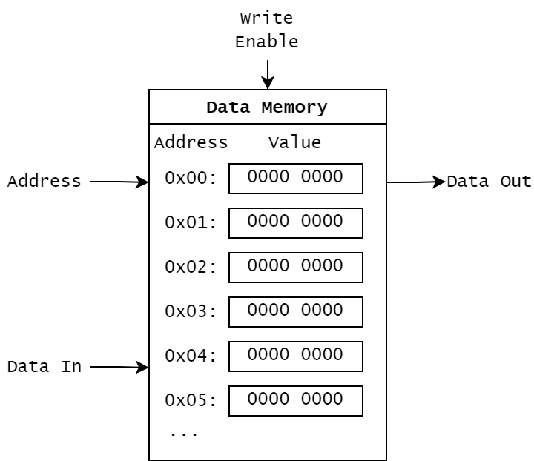

Fig 5.1.1: Symbolic representation of the data memory module

The maximum amount of memory that the CPU can access at any given time is equal to the number of unique values that can be represented on the address input. On the i281e, the address input for both the code memory and data memory modules is both 8 bits wide. This tells us that CPU can access up to 256 unique addresses per module.

On both the code memory and data memory modules, not all addresses refer to the same device. For example, the code memory module contains both RAM (Random Access Memory) and ROM (Read Only Memory). To determine which of the two memories is accessed, the code memory module looks at the provided address. If the address is below 128 (0x7F), the module accesses memory from ROM. If the address is above or equal to 128, the module accesses memory from RAM. The relationship can be represented as a memory map. A memory map shows what devices exist at specific address ranges in an address space.

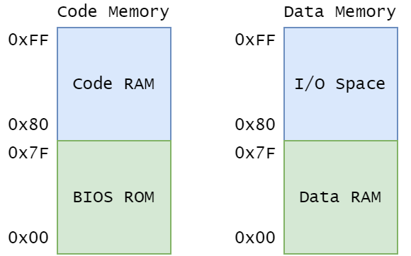

Fig 5.1.2: Memory map of code memory and data memory

The Y axis of memory map represents the different addresses in memory. Due to the way that address decoding hardware is set up, different devices end up getting mapped to different ranges of memory.

# 5.2: Bank Switching

As previously mentioned, the i281e can address up to 256 bytes of data memory, or 256 words of instruction memory. This amount of memory is adequate for extremely simple programs, but anything useful is going to require more memory. The easy solution would seem to be just adding more memory. However, this is not as simple as it seems. When more memory is added to the system, the size of the address space increases. It does not matter if the system physically has more memory if it cannot represent the addresses needed to access them. To properly increase the address space, we would need to widen the address byte from 8 bits to something wider. This raises the following issues:

1. Increasing the address space requires dramatically changing the hardware of the system. Modules like the program counter would need to be expanded, and significant parts of the data path would need to change to allow for larger data memory addresses. Likely, the only elegant way to pull this off is to increase the bit width of the entire machine from 8 bits to 12 or 16 bits.
2. Existing software will expect the address space to be a certain size. By increasing the size of the address space, we would need to rewire all existing software to include these larger addresses.

So, how can we have our cake and eat it too? Is there a way that we can keep the address space the same while simultaneously increasing the amount of memory in the system? The solution to this problem comes in the form of memory management.

By using memory management, we can translate the 8-bit virtual address supplied by the processor into a physical address that is larger. For the i281e processor, we will be using a memory management technique known as bank switching. This works by moving fixed-sized banks of physical memory in and out of the virtual address space. Bank switching isn’t without drawbacks, but it is very simple to implement in hardware.

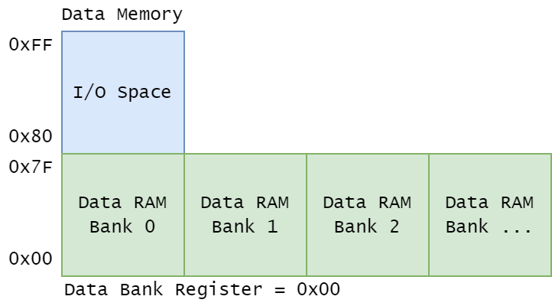

Fig 5.2.1: Data memory map with bank switching

By changing the value of the “Data Bank Register”, the portion of physical RAM that can be accessed in addresses 0x00 – 0x7F changes. The top of data memory, 0x80 – 0xFF, is not influenced by the bank register and is always accessible.

The hardware implementation of bank switching is very simple. To generate the physical address that is sent to RAM chip, the memory module combines the virtual address from the processor and the bank register. What results is a memory address that is larger than the virtual address from the processor but requires no redesign of the data path or instruction set.

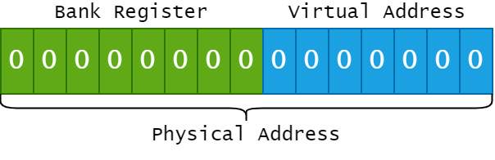

Fig 5.2.2: Conversion of virtual address to physical address

On the i281e, the lower 7 bits of the virtual address and the 8 bits of the bank register are combined to get a 15-bit address. As a result, the machine can address 32Kb of data memory, and 32KW of code memory. The 8th bit of the virtual address excluded from physical address generation on both the data and instruction memory modules. On data memory, the 8th bit is used to select between accessing RAM (Bit 7 == 0) and accessing I/O space (Bit 7 == 1). On code memory, the 8th bit selects between code RAM (Bit 7 == 1), and BIOS ROM (Bit 7 == 0).

The data memory and code memory modules have bank registers that are independent of each other. To write to the code memory bank register, the *BANK* instruction is used. To write to the data memory bank register, the data memory address 0x80 must be written to.

|  |
| --- |
| Assembly Code |
| ; SET DATA BANK TO 23  LOADI A,23  STORE [0X80],A  ; SET ISR BANK TO 2  LOADI A,2  BANK A |

Fig 5.2.3: Writing to bank registers in assembly

An obvious tradeoff to using bank switching is that only a small portion of memory can be exposed at a single time. To move information from one bank to another, it must be temporarily stored the CPU registers while the banks are swapped out. This results in a performance hit as well as more complicated software.

# 5.3: Physical Memory Access

Computer memory is a simple idea conceptually. Programmers rarely need to think about how the data is physically stored on the hardware. However, this simplicity does not survive contact with the real world. Computer memory has historically been an extremely difficult problem to solve. There is a constant tradeoff between size, speed, cost, reliability, availability, and interface complexity. To fully understand how the i281e works, we will need to explore exactly how the processor interfaces with memory.

Computer engineers have come up with a wide variety of methods for storing rapid access information over the years. These methods are specifically for storing programs or intermediate data during computation. We will talk about mass storage in Chapter 6.

* **Gate Memory:** Bits are stored in flip-flops created using logic gates. This is the simplest way of creating computer memory, but it is costly and size inefficient. Traditionally used for registers.
* **Drum Memory:** Bits are magnetically recorded on the surface of a drum that spins at high speed. This was one of the first methods used to store large amounts of information on computers. The issue with this is that bits can only be accessed when the drum rotates to their location. Performance is bad, and random access is impossible.
* **Delay Lines:** Bits are encoded as sonic pulses in some sort of substrate. The first versions of this idea used massive tanks of liquid mercury. Same issues as drum memory.
* **Williams Tubes:** Bits are stored as bits of charge of the surface of a cathode ray tube. This is one of the first attempts of creating random access memory, meaning any bit can be accessed at any time.
* **Core Memory:** Bits are stored in small magnetic rings. These rings are woven into a cloth-like matrix using wire. This is the first successful random access memory technology. An interesting “feature” of core memory is that reading a bit will also erase the bit. This technology was used up until the mid-1970s.
* **Dynamic RAM:** Bits are stored in tiny capacitors on a silicon die. With the invention of integrated circuits, it became possible to build extremely small circuits. In dynamic memory, the “cells” need to be constantly refreshed by the hardware to keep their value, regardless of if they are being accessed or not. This form of memory is still in use today for most computer RAM.
* **Static RAM:** Bits are stored like gate memory, but everything is built on a silicon die. These memory chips are faster than dynamic RAM, and do not require refreshing. However, they are more expensive and have lower capacities. Used in modern computers as cache memory.

For the i281e, we chose to use the form of memory that was easiest to interface. This ended up being static RAM. Due to the relative simplicity of the i281e, we accepted the smaller capacities for static RAM chips in exchange for not having to deal with refresh logic. Specifically, the data memory and code memory modules both use *62256* SRAM chips for storage. Each one of these parts stores 32Kb of data with a width of 8 bits.

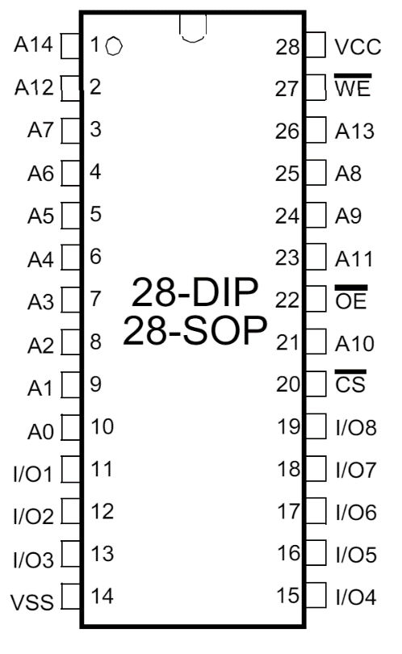

Fig 5.3.1: Pinout of the 62256 SRAM integrated circuit

To access a byte from the *62256* IC, the following must be done.

1. The binary address of the byte must be provided to the chip through the address lines (*A0 – A14).*
2. The control signals (*\*WE, *OE, *CS*) must be asserted depending on of a read or write needs to happen.
3. The value of the I/O lines (*I/O0 – I/O7*) will either be written, or the I/O lines will be asserted with the value read.

The important thing to notice about this simplified process is that the I/O lines can either be inputs or outputs depending on what function the chip is performing. This is because the *62256* is designed to work on a bi-directional bus. In this scenario, the memory chip can read a value from the bus, or “assert” a value onto the bus. When the *62256* is not being used, it will set the I/O pins to high impedance (or “High Z”). When a pin is set to high z, it is electrically disconnected from the bus. This concept is known as three-state logic.

The most important thing to know about using the bidirectional bus is that only one device at a time can assert onto the bus. It doesn’t matter if the device is asserting a logic high or logic low. We need to design our logic carefully to ensure that no two devices try to assert at the same time. On the *62256*, we do this using the control lines.

* **\*CS:** Chip select. This pin is used to enable the chip. Otherwise, all I/O pins are set to high z regardless of the state of the other control signals.
* \***RD:** Read strobe. This pin is used to read a value from the SRAM chip. The cell addressed by the address lines is asserted onto the I/O pins.
* **\*WR:** Write strobe. This pin is used to write a value onto the SRAM chip. The cell addressed by the address lines is set to the current state of the I/O pins. The cell is constantly updated until the *\*WR* line is no longer asserted.